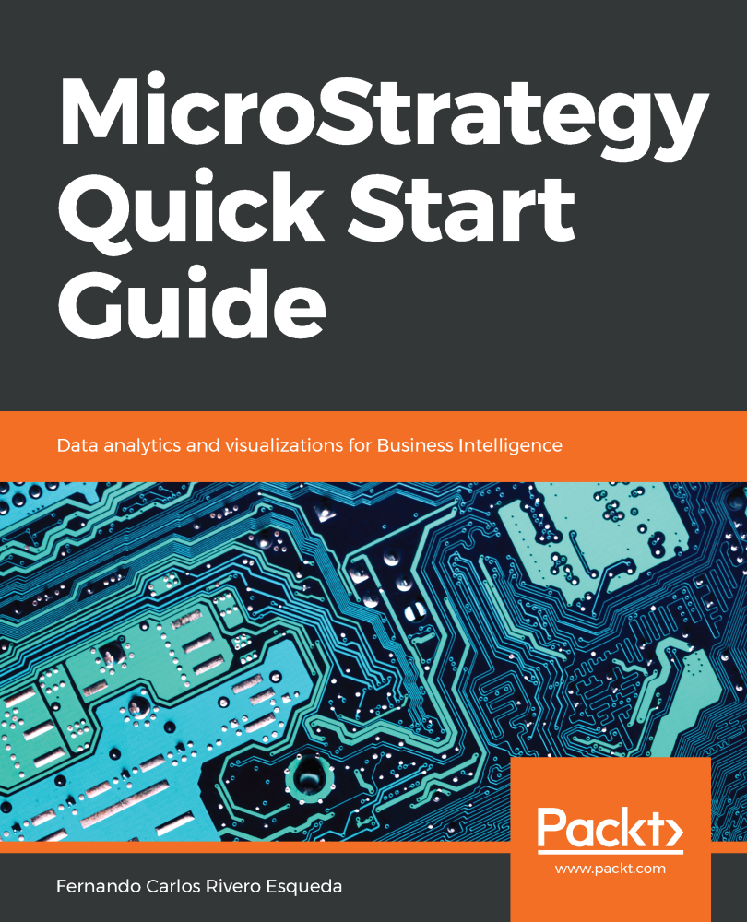

**MicroStrategy Quick Start Guide**

Copyright © 2018 Packt Publishing

All rights reserved. No part of this book may be reproduced, stored in a retrieval system, or transmitted in any form or by any means, without the prior written permission of the publisher, except in the case of brief quotations embedded in critical articles or reviews.

Every effort has been made in the preparation of this book to ensure the accuracy of the information presented. However, the information contained in this book is sold without warranty, either express or implied. Neither the author, nor Packt Publishing or its dealers and distributors, will be held liable for any damages caused or alleged to have been caused directly or indirectly by this book.

Packt Publishing has endeavored to provide trademark information about all of the companies and products mentioned in this book by the appropriate use of capitals. However, Packt Publishing cannot guarantee the accuracy of this information.

**Commissioning Editor:**Amey Varangaonkar  
**Acquisition Editor:** Reshma Raman  
**Content Development Editor:** Mohammed Yusuf Imaratwale  
**Technical Editor:** Jinesh Topiwala  
**Copy Editor:** Safis Editing  
**Project Coordinator:** Hardik Bhinde  
**Proofreader:** Safis Editing  
**Indexer:**Priyanka Dhadke  
**Graphics:**Jason Monteiro / Fernando Carlos Rivero Esqueda  
**Production Coordinator:**Aparna Bhagat

First published: September 2018

Production reference: 1270918

Published by Packt Publishing Ltd.  
Livery Place  
35 Livery Street  
Birmingham  
B3 2PB, UK.

ISBN 978-1-78913-624-1

[www.packtpub.com](http://www.packtpub.com/)

# Preface

Founded in 1989, MicroStrategy has been consistently recognized by Gartner as a business intelligence and analytics leader in technology. For almost 30 years, companies and organizations all over the world have trusted MicroStrategy to provide them with one of the best analytics, reporting, and mobile platforms. Nevertheless, the MicroStrategy platform can be daunting at first sight. The amount of concepts and information about MicroStrategy, combined with so many advanced features, a steep learning curve, costly courses, and limited literature, could discourage almost anyone. Moreover, the few books in the market are focused on advanced features and written for an audience with some degree of experience in business intelligence and reporting applications.

This book's objective is to help users and developers take the first step toward learning MicroStrategy by providing a good, solid foundation in a format that is easy to read and understand. The base concepts and skills learned by completing this book will aid the audience in moving to the next level in their knowledge of MicroStrategy.

# Who this book is for

This book is tailored toward business and information technology professionals with little or no experience in MicroStrategy, who want to learn the basics and start building reports right away. Also, this book can be easily adopted by professionals with experience in other business intelligence reporting platforms and tools.

# What this book covers

[Chapter 1](https://learning.oreilly.com/library/view/microstrategy-quick-start/9781789136241/19f2500c-9b42-40c7-afcb-a1a6924db287.xhtml), Architecture – Installing and Configuring MicroStrategy, introduces the reader to MicroStrategy, how its technology fits into the business intelligence spectra, and how it satisfies information demands for any organization. MicroStrategy architecture is presented and explained. Client applications, such as Developer and Web, are described, as well as server components. This chapter also describes how to install the MicroStrategy Intelligence Server, as well as the client tools used to build and maintain MicroStrategy Reports and analytics objects.

[Chapter 2](https://learning.oreilly.com/library/view/microstrategy-quick-start/9781789136241/fd4af412-abaf-48a5-b2d6-35619439116e.xhtml), Project Design – Creating Your Project Foundation, teaches the reader about MicroStrategy Objects, specifically about Schema Objects, which are used to create an abstraction or model of an analytical database or data warehouse. These objects serve as the foundation for the MicroStrategy Project. Each object is described and explained: what it its main purpose; how to build it, in terms of what its components are; and where it can be reused.

[Chapter 3](https://learning.oreilly.com/library/view/microstrategy-quick-start/9781789136241/4c09a3f2-6bed-4926-8cd3-480d5b9f9793.xhtml), Basic Reporting – Building Your First Reports, introduces to the reader the Public or Application Objects and how these objects are built from Schema Objects. The first reporting objects, such as Templates, Filters, and Metrics, are described and explained. At the end of the chapter, several Report manipulations are described.

[Chapter 4](https://learning.oreilly.com/library/view/microstrategy-quick-start/9781789136241/a9f0f9b0-f8bf-4689-aef9-e0f8d002b291.xhtml), Advanced Reporting – Interacting with and Improving Your Reports, continues to introduce new Public Objects to the reader; this time,  they are objects that will allow them to step up their analysis, flexibility, and performance. Intelligent Cubes are discussed and explained as a way to publish information so that MicroStrategy reporting applications can consume it.

[Chapter 5](https://learning.oreilly.com/library/view/microstrategy-quick-start/9781789136241/649fcb73-c184-421f-8c88-cfd90e5f4090.xhtml), Dashboarding – Creating Visual Reporting, covers visual information and dashboarding. It shows the reader how to import a data source and then create a Dashboard using Public Objects for enterprise-certified reporting, or to create a web Dashboard using self-service tools.

[Chapter 6](https://learning.oreilly.com/library/view/microstrategy-quick-start/9781789136241/fc2effe1-1dd1-406c-94d4-4bc6d06b96ae.xhtml), Security – Managing Your Users and Their Access, introduces Configuration Objects to the reader, and covers the main security levels in MicroStrategy. Some of these objects allow administrators to set up security profiles and permissions to access objects and to create Users and Groups.

[Chapter 7](https://learning.oreilly.com/library/view/microstrategy-quick-start/9781789136241/aac45770-f3d9-4af3-913d-55f7105d3290.xhtml), Administration – Maintaining and Monitoring your Project, expands the knowledge about other Configuration Objects describing those which allow system administrators to perform tasks such as establishing database connectivity and scheduling data refreshes for their Reports and Intelligent Cubes. Then, the main system monitors are presented and described. Finally, three Administrative client tools are described: Object Manager, Command Manager Integrity Manager.

[Appendix](https://learning.oreilly.com/library/view/microstrategy-quick-start/9781789136241/ebf7660d-dedf-404f-8f85-3e5f2b43049a.xhtml), Quick Reference Tables by Object Type, is a collection of all the quick reference tables used throughout the book by object type, for readers to reference.

# To get the most out of this book

This book requires a general understanding of application software and common graphical user interface applications, such as Windows Explorer. In addition, it is assumed that the reader understands basic business intelligence concepts and database terminology (tables, columns, fields, rows, and so on).

 A PC with a Windows 64-bit operating system is required. Also, to get the most out of all the exercises, the following software should be installed (in addition to MicroStrategy):

* Microsoft .NET Framework 4.0 or higher
* Internet Explorer or Google Chrome
* Internet Information Services (IIS 10 or higher)
* Microsoft Access (2007 or newer)

For a detailed list of system requirements, you can check <https://microstrategyhelp.atlassian.net/wiki/spaces/README104/pages/38305888/MicroStrategy+10.4+System+Requirements>.

**Download the example code files**

You can download the example file for this book from your account at [www.packt.com](http://www.packt.com/). If you purchased this book elsewhere, you can visit [www.packt.com/support](http://www.packt.com/support) and register to have the files emailed directly to you.

You can download the file by following these steps:

1. Log in or register at [www.packt.com](http://www.packt.com/).
2. Select the SUPPORT tab.
3. Click on Code Downloads & Errata.
4. Enter the name of the book in the Search box and follow the onscreen instructions.

Once the file is downloaded, please make sure that you unzip or extract the folder using the latest version of:

* WinRAR/7-Zip for Windows
* Zipeg/iZip/UnRarX for Mac
* 7-Zip/PeaZip for Linux

The example file for the book is also hosted on GitHub at <https://github.com/PacktPublishing/MicroStrategy-Quick-Start-Guide>. In case there's an update to the file, it will be updated on the existing GitHub repository.

We also have other code bundles from our rich catalog of books and videos available at <https://github.com/PacktPublishing/>. Check them out!

# Download the color images

We also provide a PDF file that has color images of the screenshots/diagrams used in this book. You can download it here: <http://www.packtpub.com/sites/default/files/downloads/9781789136241_ColorImages.pdf>.

**Architecture - Installing and Configuring MicroStrategy**

There are a good number of solutions, tools, and software that help companies and organizations to make sense of their data by turning it into information. This information needs to be analyzed and visualized in such a way that it can generate knowledge and insight into the past, present, and future of the organization.

This cycle of “data-information-knowledge-action” is commonly known as “business intelligence” or “business analytics”, depending on the ‘usage of that knowledge’ and the focus and perspective of those who make decisions.

In simple terms, we can think of business intelligence as a way to maintain and optimize the present by looking into the past, whereas business analytics focuses on transforming the future by changing the present. MicroStrategy has been one of the market's leading business intelligence and analytics platforms since 1989.

This first chapter will introduce the MicroStrategy platform and explain its main components. Then it will cover MicroStrategy installation and configuration so that readers can start creating their first project and reporting applications right away. The following topics will be covered:

* MicroStrategy architecture
* Intelligence Server engines description
* Intelligence Server components description
* Web and mobile server description
* Client applications for developers
* Client applications for administrators
* Client applications for information delivery
* Installation and configuration
* The MicroStrategy metadata
* Creating and configuring project sources

# MicroStrategy architecture

MicroStrategy is a platform suite which satisfies both **Business intelligence** (**BI**) and **Business** **Analytics** (**BA**) needs within an organization. It features powerful application software capable of resolving any question related to the past, present, or future of a given company, making MicroStrategy one of the best platforms for BI and BA in the market.  
  
MicroStrategy is capable of covering all BI/BA styles from basic reporting, OLAP business analysis, scorecards and dashboards, to more sophisticated predictive analytics and data mining.

MicroStrategy is a hybrid online analytical processing platform, also known as HOLAP.

* It is capable of generating queries or a **SQL** (**Structured Query Language**) from virtually any major relational database, such as Oracle, Teradata, Redshift, SQL Server, and so on. This is what gives MicroStrategy its **ROLAP** (relational online analytical processing) capabilities.
* However, it could also work as a **MOLAP** (multidimensional online analytical processing) with the use of cube structures.

As a developer, it is important to understand MicroStrategy's architecture. The following diagram depicts how MicroStrategy's components commonly fit into the big picture of BI/BA within an organization:

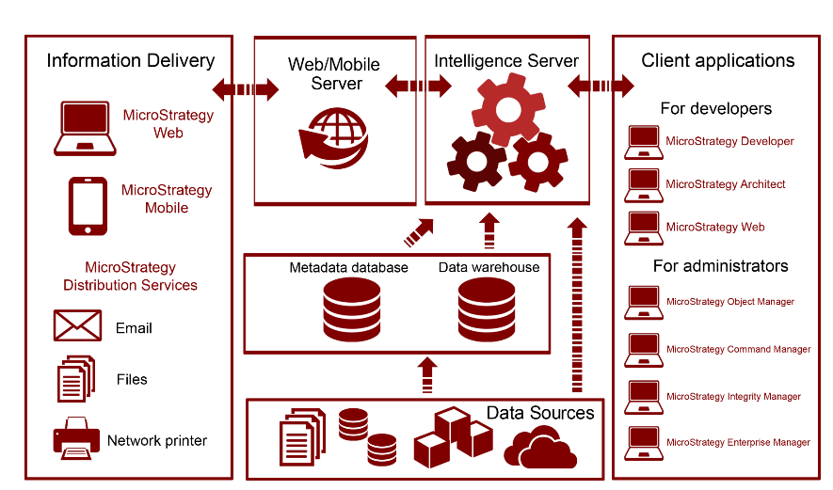

Microstrategy's architecture

At MicroStrategy's platform core resides the Intelligence Server, which connects to a data layer.

This data layer acts as a data source, and it could be a relational database with enterprise data, such as a data warehouse or a specialized data mart. However, the Intelligence Server can also connect to a nonrelational data source such as transactional applications (OLTP), flat files, cube data structures, and website content, to name a few.   
  
There is also a metadata database or repository that the Intelligence Server uses to store the definitions of all MicroStrategy objects.

There are three main groups of client applications, or tools, within the MicroStrategy suite.

* First, there are client applications, which allow developers to create reporting and analytics solutions. These applications are
  + MicroStrategy Developer,
  + MicroStrategy Architect and
  + MicroStrategy Web.
* Next, the information is delivered to the final user or analyst via
  + MicroStrategy Mobile,
  + MicroStrategy Web,
  + Email, Printer, or
  + File (using MicroStrategy Distribution Services, Narrowcast Server, or MicroStrategy Office).
* Finally, there are some applications with the purpose of managing and monitoring the business intelligence projects. Some examples are
  + MicroStrategy Object Manager,
  + MicroStrategy Command Manager,
  + MicroStrategy Enterprise Manager, and
  + MicroStrategy Integrity Manager.

*Narrowcast Server is an information delivery application that is being replaced by Distribution Services.*

In the following sections, you will learn in detail how each component fits into the whole architecture, resulting in a robust business intelligence and analytics platform.

# Main server components

There are two main server groups in the MicroStrategy architecture.  
The core of the MicroStrategy platform is an application server called Intelligence Server.   
There are also two servers that will publish the information to the appropriate delivery method. These servers are the Web and Mobile servers. In the following sections we will learn about them.

**The MicroStrategy Intelligence Server**

The following diagram shows where the Intelligence Server resides within the platform's architecture:

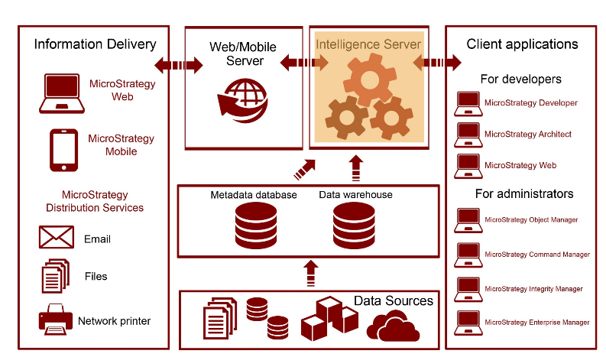

The application server responsible for orchestrating every other component in the MicroStrategy platform is the Intelligence Server, also called I-Server. It is also the component that handles communication with the data sources (such as data warehouse or nonrelational databases) and the metadata database. There are three main I-Server engines, shown as follows:

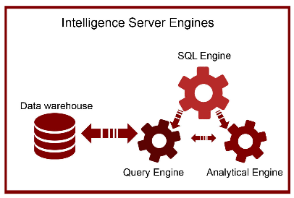

* **SQL Engine**The SQL Engine is responsible for creating the optimized SQL for the database. Once the SQL is generated, the I-Server SQL Engine will pass it to the Query Engine for execution. The SQL Engine also controls the other two engines.
* **Query Engine**The Query Engine is responsible for sending the SQL towards the database. The I-Server Query Engine will connect to the database via ODBC (Open Database Connectivity) and execute the query. Once the SQL is executed, it will receive it and send it to the Analytical Engine for cross tabbing or additional nonSQL functions.
* **Analytical Engine**The Analytical Engine is responsible for nonSQL actions such as in-memory manipulations and cross tabbing. Some typical examples of calculations not resolved by the SQL are functions that are not commonly supported by the database like rankings, subtotals, and other OLAP functions. This engine is also responsible for laying out the data in a cross-tab format.   
  Finally, the Analytical Engine is in charge of any in-memory manipulation of the report (this is after the dataset is returned from the database) such as pivoting, Page-by, sorting, and conditional formatting.

In addition, there are three I-Server components that allow scalability, optimization, and distribution of the information:

* **OLAP Services**MicroStrategy OLAP Services enable MOLAP capabilities with the creation and manipulation of in-memory datasets called Intelligent Cubes. (For more information refer to [Chapter 4](https://learning.oreilly.com/library/view/microstrategy-quick-start/9781789136241/a9f0f9b0-f8bf-4689-aef9-e0f8d002b291.xhtml), *Advanced Reporting - Interacting with and Improving Your Reports*).
* **Report Services**MicroStrategy Report Services allow flexible reporting layouts to create dashboards and scorecards. (For more information refer to [Chapter 5](https://learning.oreilly.com/library/view/microstrategy-quick-start/9781789136241/649fcb73-c184-421f-8c88-cfd90e5f4090.xhtml), *Dashboarding - Creating Visual Reporting*).
* **Distribution Services**MicroStrategy Distribution Services facilitate the delivery of reports and dashboards supporting multiple formats, schedules, and transmitters such as email, printers, and file servers.

# MicroStrategy Web and Mobile servers

The following diagram shows where Web and Mobile servers reside within the platform's architecture:

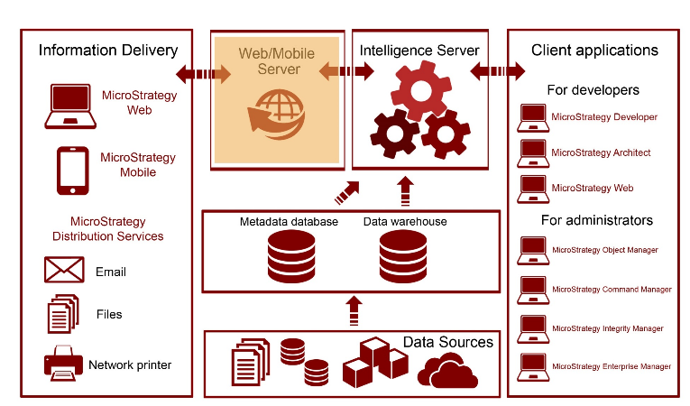

Apart from the Intelligence Server, there are other two server components that connect to the information delivery face of the architecture. These servers are MicroStrategy Web and Mobile. The software components of MicroStrategy Web and Mobile are deployed and published using a web server such as Tomcat or IIS.   
These two communicate with the MicroStrategy Intelligence Server in order to deliver information to the corresponding Web and Mobile client counterparts.

# Client applications

The MicroStrategy platform provides a complete set of client tools and applications that enable developers to build and design BI and analytics solutions, administrators to manage BI projects and their life cycle, and users to interact with data, and to discover and analyze it correspondingly.

All these client applications connect to the Intelligence Server, which manages them and controls how, when, and where the data and information should be directed.

**For developers**

The following diagram shows where developer tools reside within the platform's architecture:

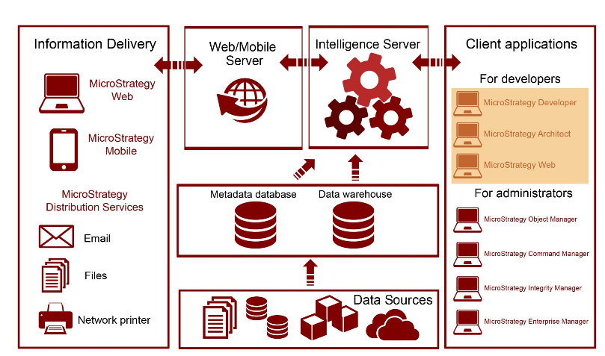

The first client tools are the ones used for design and developing. The applications are MicroStrategy Developer, MicroStrategy Architect, and MicroStrategy Web:

* **MicroStrategy Developer**Formerly known as MicroStrategy Desktop, MicroStrategy Developer is an application that gives developers the ability to create reporting and analytics solutions. This is the tool that power users or advanced developers utilize to build Public Objects, which include Reports, Metrics, Filters, and dashboards.   
  MicroStrategy Developer also contains administrative features to configure, monitor, and secure the BI project.
* **MicroStrategy Architect**MicroStrategy Architect is embedded into MicroStrategy Developer's interface and enables designers and developers to create objects that map to the database structures. These objects are called schema objects. (For more information refer to [Chapter 2](https://learning.oreilly.com/library/view/microstrategy-quick-start/9781789136241/fd4af412-abaf-48a5-b2d6-35619439116e.xhtml), *Project Design - Creating Your Project Foundation*).
* **MicroStrategy Web**MicroStrategy Web is a light client application that permits both developing and performing interactive analysis. It provides a wide range of options, from data browsing, report manipulation and dashboard creation, to self-service, information distribution, and data discovery. In some, this client is used by both developers and final users as well.

**For administrators**

The following diagram shows where administrator tools reside within the platform's architecture:

The second set of client components includes those used for administration, script automation, monitoring, and managing the BI life cycle. Some applications are MicroStrategy Object Manager, MicroStrategy Command Manager, MicroStrategy Enterprise Manager and MicroStrategy Integrity Manager:

* **MicroStrategy Object Manager**MicroStrategy Object Manager allows administrators to copy or promote objects across different environments such as nonproduction, test, and production.
* **MicroStrategy Command Manager**MicroStrategy Command Manager gives the administrators the ability to create scripts to automate the most common administrative tasks. Third-party applications such as BMC Control-M and Airflow, can be integrated with MicroStrategy using Command Manager.
* **MicroStrategy Enterprise Manager**MicroStrategy Enterprise Manager enables analysis of the information generated by the Intelligence Server and the project's usage. It provides a set of Reports and Dashboards that allow administrators to monitor system and report usage, as well as statistics that can be leveraged to create strategies to optimize the BI and analytics environment.
* **MicroStrategy Integrity Manager**MicroStrategy Integrity Manager gives developers a tool to compare environments and the objects within, identifying and highlighting changes or differences that could occur between development, test, and/or production environments.

**For users and analysts**

The following diagram shows where information delivery tools reside within the platform's architecture:

The third set of client applications includes the ones that deliver the information to the final users and analysts. These clients are MicroStrategy Web, MicroStrategy Mobile, and MicroStrategy Distribution Services:

* **MicroStrategy Web**MicroStrategy Web not only serves as software for development but also as a web-based client that delivers rich visualizations, powerful report manipulations, and interactive dashboards. MicroStrategy Web is integrated with MicroStrategy Distribution Services to deliver information in a variety of formats and media, such as email, files, or printed material.
* **MicroStrategy Mobile**MicroStrategy Mobile delivers reports and dashboards anytime and anywhere to tablets and phones such as iPads, iPhones, and Android phones and tablets. MicroStrategy Mobile is fully integrated with the MicroStrategy platform, which allows it to use its report manipulation and visualization features, its flexibility, and at the same time provide security and scalability.
* **MicroStrategy Distribution Services**MicroStrategy Distribution Services is the component of MicroStrategy Intelligence Server that performs the delivery of reports and dashboards in a full range of methods or locations (email, files, MicroStrategy history lists, or network printers) and formats (Excel, PDF, HTML, CSV, text, and so on).

# Installation and configuration

The information conveyed in this section provides the prerequisites and minimum system requirements to install the current MicroStrategy, version 10.X. For prior versions, similar prerequisites apply. To make sure the requirements are met, check the MicroStrategy Release Notes (Readme file) that are included with the packaged installation files. In addition, MicroStrategy Online Community (<https://community.microstrategy.com/s/>) is a great place to find documentation, forums and the latest information about MicroStrategy.

**Prerequisites**

Before installing the MicroStrategy suite you must make sure these prerequisites are covered:

* MicroStrategy installation files: Typically downloaded from the MicroStrategy download site in a compressed file.
* License Key: Obtained from MicroStrategy account executive. MicroStrategy can also be downloaded and installed on a 30-day free trial.
* Administrative privileges: On a Windows installation it is necessary to have a domain account with administrative privileges and access is required. For Unix/Linux, root access is necessary.

Required software:

* For Windows:
  + Microsoft .NET Framework 4.0 or 4.5
  + Web server (to support MicroStrategy Web on ASP.NET) Microsoft Internet Information Services 7.x-8.x
* For Linux/Unix:
  + Web server (to support MicroStrategy Web on J2EE) such as Oracle WebLogic 12c or 10.3.x, IBM WebSphere 7.x-8.0.X, or Apache Tomcat 6.0.x-7.0.X

**System requirements**

The following table serves as a guideline for the MicroStrategy 10 platform installation. These include recommended memory, available storage, and processor for each component.

|  |  |  |  |
| --- | --- | --- | --- |
| **MicroStrategy component** | **Minimum memory** | **Storage** | **Hardware** |
| MicroStrategy Intelligence Server | 4 GB | 12 GB (as a rule, memory times 3) | Windows: 64-bit |
| MicroStrategy Web (Server) | 4 GB | 0.5 GB | Windows: 64-bit |
| MicroStrategy Mobile  (Server) | 4 GB | 0.5 GB | Windows: 64-bit |
| MicroStrategy Developer (including Architect) | 2 GB | 0.25 GB | Windows: 64-bit or 32-bit |
| MicroStrategy Object Manager | 1 GB | 0.25 GB | Windows: 64-bit or 32-bit |
| MicroStrategy Command Manager | 2 GB | 0.25 GB | Windows: 64-bit or 32-bit |
| MicroStrategy Enterprise Manager | 1 GB | 0.25 GB | Windows: 64-bit |
| MicroStrategy Integrity Manager | 2 GB | 0.25 GB | Windows: 64-bit |

Notes:

For Linux/Unix the recommended hardware is:

* Oracle SPARC
* IBM AIX Power Architecture
* HP-UX Intel Itanium
* Red Hat/SUSE Linux 32- and 64-bit

For a complete list of supported and certified configurations, you can google MicroStrategy certified and supported configurations. With every release, MicroStrategy Inc. publishes detailed information about system requirements and supported configurations. The current one can be found at: <https://www2.microstrategy.com/producthelp/10.10/Readme/content/certified_configurations.htm>.

**Windows installation**

To install MicroStrategy on a Windows machine, it is necessary to log in to the workstation or server using an account with administrative privileges. In addition, the database servers must be in reach (via ODBC/JDBC) from the Intelligent Server to guarantee connectivity to the data warehouse (or data marts) and metadata database.

*For development and production installations it is strongly recommended to install the Web/Mobile component on a separate machine from the Intelligent Server. Same goes for other client tools such as Enterprise Manager, Object Manager, Command Manager and Integrity Manager, it is recommended to have them installed on a separate machine too.*

The installation of MicroStrategy is simple and guided by the installation wizard:

1. Download the MicroStrategy suite.
   * For licensed customers go to the MicroStrategy download site: [http://download.microstrategy.com](http://download.microstrategy.com/).
   * There is also a free 30-day trial available at: <https://www.microstrategy.com/us/get-started/enterprise-evaluation>.
2. Locate and execute the setup file (MICROSTRATEGY.exe), shown as follows:

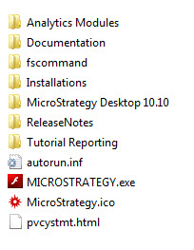

1. This action will launch the installation wizard.
2. Review and accept the license agreement and input the License Key, shown as follows:

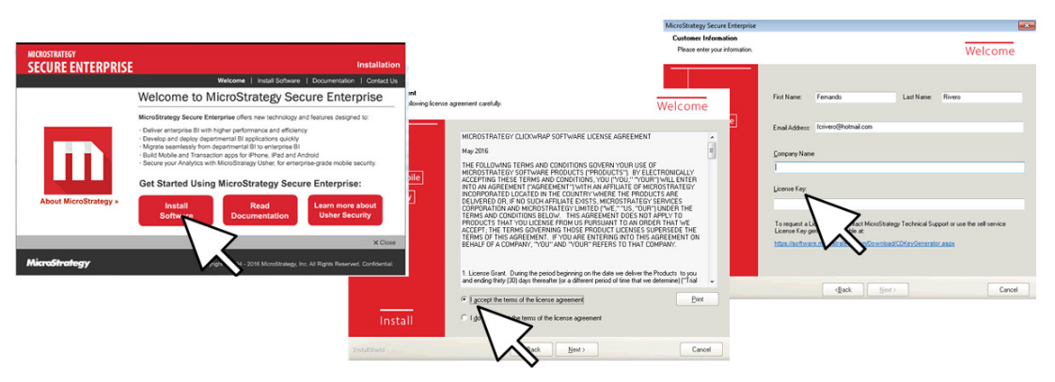

Licences agreement and Licences Key

1. Install options, including destination location and how many products in the suite will be installed, as shown in the next screenshot:

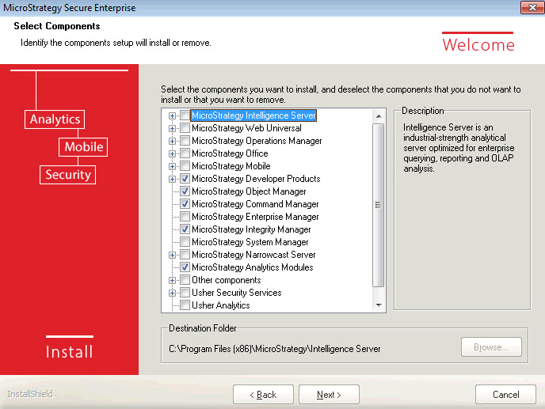

Lists of the products in the suite that will be installed

1. If MicroStrategy Web is selected, it is necessary to establish the **Internet Information Services** (**IIS**) virtual directory in which the MicroStrategy Web code (ASP.NET) will be deployed. Similarly, for MicroStrategy Mobile, a new virtual directory for the IIS will be created.
2. Continue with the summary of products to be installed and start the process.
3. When the installation wizard completes, restart the computer to make sure the installation process has completed successfully.

# Unix/Linux installation

There are different installation methods for MicroStrategy on Unix/Linux, either using a **Graphical User Interface** (**GUI**), in command-line mode, or silent mode (automated). The GUI mode and the command-line mode will launch the MicroStrategy Installation Wizard displaying the same pages and requesting the same information as the Windows counterpart. It is important to note, though, that MicroStrategy Object Manager , MicroStrategy Developer and MicroStrategy Enterprise Manager can't be installed in a Unix/Linux box.

# The MicroStrategy metadata

By definition, a metadata is "data about the data." It is usually a file or database that describes another set of data or information. In MicroStrategy, the metadata repository is a database that contains the definitions of database objects such as tables and fields in a way that developers and users can easily understand. The MicroStrategy metadata could be thought of as a logical bridge between the technicalities of the database and the business terms, measures, and contexts of the organization.

The MicroStrategy metadata maps logical abstractions, called objects, to physical database objects, as illustrated in the following diagram:

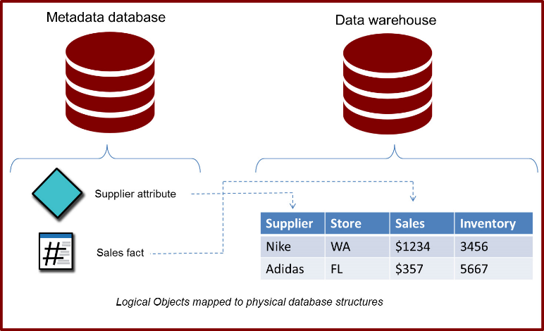

**Creating and configuring MicroStrategy metadata**

Before creating the MicroStrategy metadata, it is necessary to have the following two prerequisites ready:

* A blank database (Amazon Redshift, DB2, Informix, Impala, SQL Server, Oracle, and so on. For a complete list of certified MicroStrategy metadata databases, check the Readme file or release notes corresponding to the version you are installing.)
* A DSN (Data Source Name) using the corresponding ODBC/JDBC driver to that blank database.

*MicroStrategy Connectivity Wizard can also be used to create a DSN.*

The steps to create the MicroStrategy metadata are:

1. Open the MicroStrategy Configuration Wizard (macfgwizw.EXE). This tool will let you create a MicroStrategy metadata, configure an Intelligence Server, and create a project source among other configuration tasks, as shown in the following screenshots:

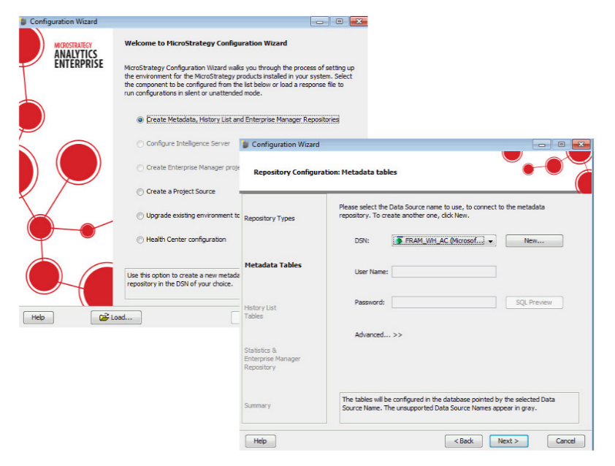

1. Select the corresponding option for metadata creation: | Create Metadata, History List and Enterprise Manager Repositories.
2. Select a DSN. The DSN will have the connectivity information and driver to access the blank database using ODBC/JDBC protocol.
3. Follow the review window and click Next until the metadata table creation starts.
4. During the creation of the MicroStrategy metadata, the MicroStrategy Configuration Wizard creates an empty shell with table structures that will host data about the data. The data that will be later populated within the structures is what we will refer to as MicroStrategy objects. This concept will be explained in the next chapter.

**Intelligence Server configuration**

Once the Intelligence Server is installed, it needs to be pointed to a MicroStrategy metadata. Once again the Configuration Wizard is used to perform this task. The object resulting from configuring an Intelligence Server is called a Server Definition. In order to create one, it is necessary to take into consideration the following prerequisites:

* The Configuration Wizard must be executed directly from the same machine where the Intelligence Server is running
* A DSN pointed to the MicroStrategy metadata database must be created in the same machine where the Intelligence Server is running

The steps to configure an Intelligence Server, pointing it to a MicroStrategy metadata are:

1. Launch the MicroStrategy Configuration Wizard (if you proceed from the above procedure, the MicroStrategy metadata creation, this wizard should be already open for you).
2. Select the corresponding option for the Intelligence Server configuration: | Configure Intelligence Server.
3. Select a DSN. This DSN must point to the metadata.
4. Once the DSN information is entered, it is necessary to either create or select an existing Server Definition.
5. The configuration process begins with the Intelligence Server being stopped, then it is pointed to the specified metadata and automatically started again, completing the Server Definition creation or switching to a different one.

**Project sources (2-tier and 3-tier)**

Once the MicroStrategy metadata is built and the Intelligence Server configured, it is necessary to create one or more Project Sources. A Project Source could be defined as a direct or indirect access point to the metadata. It is used by MicroStrategy Developer and other client interfaces to build, interact, and manage the contents of the MicroStrategy metadata.   
A Project Source can be created using the MicroStrategy Configuration Wizard or the Project Source Manager.  
  
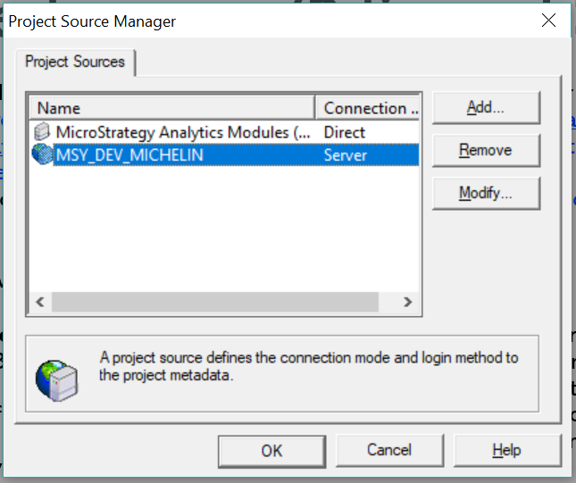

There are two types of Project Sources:

* **2-Tier (Direct)**: It is a Project Source pointed directly to a MicroStrategy metadata using an ODBC/DSN connection. This type of configuration is not recommended for production implementation since it won't guarantee mutual exclusion to the metadata. The 2-Tier configuration, illustrated in the following diagram, is only recommended for some maintenance and administrative tasks that require exclusive access to the metadata while the Intelligence Server is down.

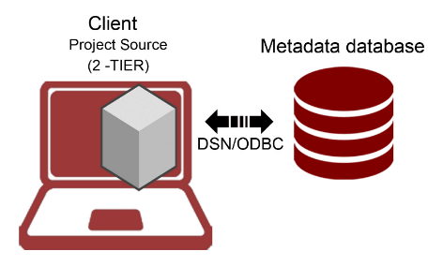

To create a 2-Tier or Direct project source it is necessary to have a DSN/ODBC connection ready pointing to the MicroStrategy metadata database and corresponding credentials. Following are steps to create it from Developer:

1. Tools Menu | Project Source Manager.
2. Provide a Project Source name.
3. Add | select in connection mode Direct.
4. Provide ODBC DSN with corresponding login and password.

The following screenshot shows what your Project Source Manager will look like:

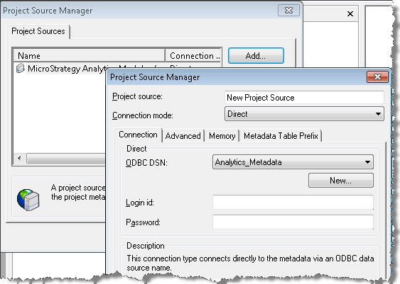

* **3-Tier (server)**: This is a Project Source pointed to the MicroStrategy Intelligence Server that in turns points to the MicroStrategy metadata. This is the configuration used for development and production. A 3-Tier configuration will guarantee that the access to the MicroStrategy metadata is controlled by the Intelligence Server providing centralization, security and fail over support (when combined with a cluster of servers). The below diagram depicts a 3-tier configuration:

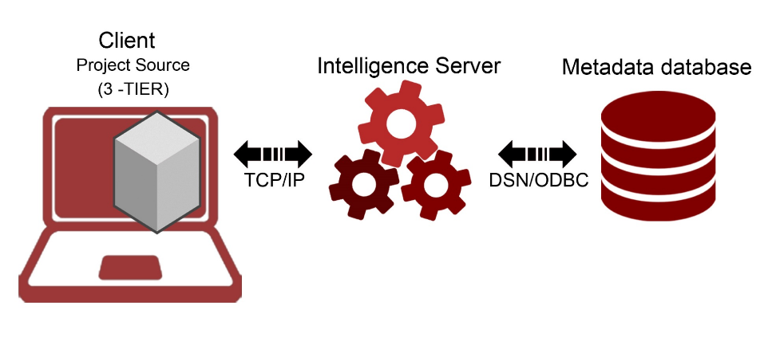

To create a 3-Tier or server Project Source, it is necessary to have the Intelligence Server IP address or server name. Follow these steps to create it from MicroStrategy Developer:

1. Go to Tools Menu | Project Source Manager.
2. Provide a Project Source name.
3. Add | select in connection mode Server.
4. Provide the Intelligence Server IP address, or server name, and a port number if applicable.

# 4-Tier configuration (MicroStrategy Web and/or Mobile)

Once the Intelligence Server is configured and pointed to a MicroStrategy metadata, the MicroStrategy Web and/or Mobile Server should be configured as well. Open the Web Administrator page, it is usually found in this URL if installed on Internet Information Services (IIS) Web Server https://<your server name>/asp/Admin.aspx . Then add the Intelligence Server IP address or domain name to connect via TCP/IP. The following diagram depicts this type of arrangement, which is called 4-Tier configuration:

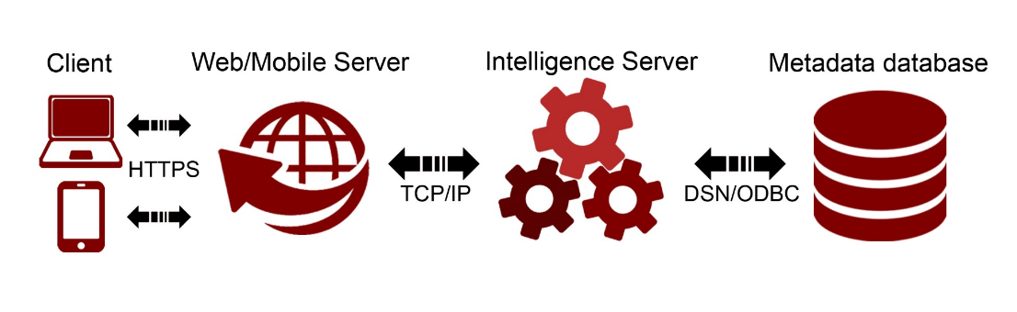

# Summary

At this point, you should be familiar with the MicroStrategy Platform architecture and understand how the different components relate to each other. Also, you should be able to install MicroStrategy and perform basic configurations such as metadata database creation, Intelligence Server configuration, and Project Source creation (in 2 and 3-Tiers).

The next chapter will introduce the important concept of MicroStrategy Objects. We will learn about a specific category, which will be the foundation for any MicroStrategy Project: The Schema Objects.

# Project Design - Creating Your Project Foundation

Technically speaking, MicroStrategy's core task is to translate business questions into the language that databases speak: SQL. In other words, MicroStrategy offers a logical bridge between business users and the data. This bridge is possible because of MicroStrategy's Objects, which in turn reside in its metadata database.

This chapter will establish the base for designing and building a MicroStrategy project. It will first define and explain the concept of MicroStrategy Objects and then describe the main object categories. Then the main Schema Objects, such as Attributes and Facts, will be covered. The following topics will be the focus of this chapter:

* What is a MicroStrategy Object?
* Which are the main object categories?
* Understanding a MicroStrategy Project and how to create one
* Understanding a MicroStrategy Schema Object
* Explaining MicroStrategy Attributes and how to create one
* Explaining MicroStrategy Facts and how to create one
* Explaining MicroStrategy Hierarchies and how to create one
* Explaining MicroStrategy Transformations and how to create one

**MicroStrategy Objects**

MicroStrategy Objects are logical abstractions of mainly database components, such as tables and columns. However, there are some objects that represent other things such as databases (connections), users, server nodes, schedules, and devices, to mention a few. All MicroStrategy Objects are stored in the MicroStrategy metadata database. In other words, if it is stored in the metadata then it must be a MicroStrategy Object.

This wide variety of MicroStrategy Objects are grouped into the following three main categories:

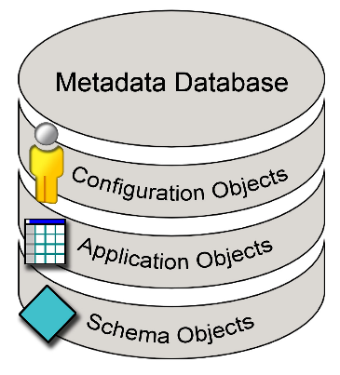

Three categories of Microstrategy

* **Schema Objects**: These objects directly represent database objects such as columns, tables, and partitions. Some examples are: Tables, Attributes, Facts, Hierarchies, and Transformations.
* **Application Objects**: Also known as Public Objects, these objects represent reporting and visualization objects. Some examples are: Reports, Templates, Metrics, Filters, Prompts, and Documents.
* **Configuration Objects**: These objects represent administration, security, and Configuration Objects. Some examples are: Users, Groups, Database Connections, and Schedules.

**Framework to learn about MicroStrategy Objects**

Some years ago, when I used to teach MicroStrategy, I utilized a very effective framework to learn about the multiple and diverse MicroStrategy Objects. This framework consists of three simple questions:

|  |  |
| --- | --- |
| 1. What is it for? | Describe the purpose of the MicroStrategy Object. |
| 1. What is it made of? | List what other MicroStrategy Objects reside within (its components) or what it represents. |
| 1. Where can it be used? | Explain in which other MicroStrategy Objects it could be embedded (its dependents). |

I will use this same framework for each MicroStrategy Object covered in this book.

# MicroStrategy Analytics Modules

When MicroStrategy is installed, there is the option to install MicroStrategy Analytics Modules. Basically, this option will install two sample projects: MicroStrategy Tutorial and Human Resources Analysis Module. These two projects are installed and configured automatically. Both the data warehouse and the metadata databases reside on Microsoft Access. In addition, a 2-Tier Project Source is also created and accessible from MicroStrategy Developer. The login is Administrator with a blank password.

It is recommended to leave these sample projects to perform testing of MicroStrategy Features and self-training in a DEV or System Test environments, never in Production. Otherwise, these could be uninstalled. Throughout this book, we will use these two projects to describe examples and perform exercises.

# MicroStrategy Developer

MicroStrategy Developer is a client interface that was conceived while thinking of an interface that the majority of the developers and users are familiar with: Windows Explorer. Microsoft Windows Explorer is a tool that helps the user to visualize, manage, organize, create, and delete files in a PC. Similarly, MicroStrategy Developer (which by the way was called MicroStrategy Desktop for many years before version 9.5) is a tool that helps the user to visualize, manage, organize, create, and delete MicroStrategy Objects in the metadata.

Although other MicroStrategy clients, covered in [Chapter 1](https://learning.oreilly.com/library/view/microstrategy-quick-start/9781789136241/19f2500c-9b42-40c7-afcb-a1a6924db287.xhtml), Architecture – Installing and Configuring MicroStrategy, will offer some specific functionality and interaction with the MicroStrategy Objects, MicroStrategy Developer is the main client to develop and manage all three object categories, as shown in the following screenshot:

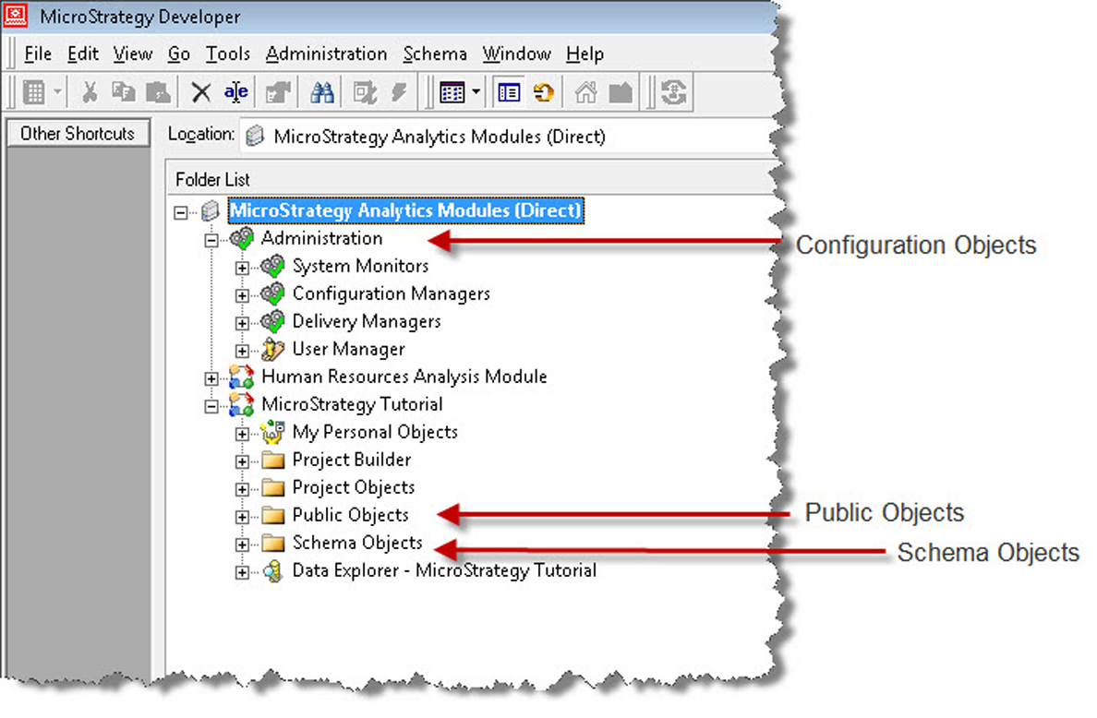

Using MicroStrategy Developer to manage all three categories

Notice that the MicroStrategy Developer tree structure is similar to that of Windows Explorer. Similarly, actions such as drag and drop, copy and paste, renaming (F2), and folder creation, to name a few, follow the same paradigm as in Windows, making MicroStrategy Developer very familiar and intuitive to the developer and user.

Although there are some folders already created by default by MicroStrategy, developers can create as many as they want, rename them, and move Schema and Public Objects arbitrarily within these. However, it is recommended to keep these objects separated for ease of administration and maintenance. Conversely, the configuration objects only reside within the section named Administration.

# MicroStrategy Projects

MicroStrategy Projects are Configuration Objects, which group all other objects within (Public and Schema).The following is a quick reference table for this MicroStrategy Object:

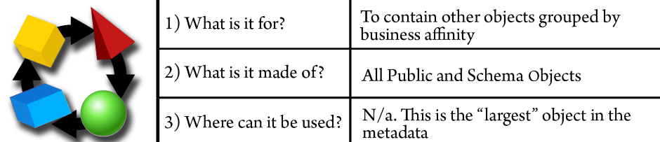

The Projects are usually created according to a business area (such as marketing, finance, and human resources) or, in some organizations, by the technology that supports its data source (such as Teradata, Oracle, SQL Server). In any case, a MicroStrategy Project helps developers and users to organize their reporting and analytics applications. There are other Configuration Objects, but these will be covered in [Chapter 6](https://learning.oreilly.com/library/view/microstrategy-quick-start/9781789136241/fc2effe1-1dd1-406c-94d4-4bc6d06b96ae.xhtml), Security – Managing Your Users and Their Access and [Chapter 7](https://learning.oreilly.com/library/view/microstrategy-quick-start/9781789136241/aac45770-f3d9-4af3-913d-55f7105d3290.xhtml), Administration – Maintaining and Monitoring Your Project.

**Project structure**

When a MicroStrategy Project is created, a general folder structure common to every project is generated:

* **My Personal Objects:** This set of folders is meant to save objects that are not shared among other users. Meaning, whatever is saved within it remains private to the logged-in user (and the MicroStrategy Administrator).
* **Project Builder**: Project Builder is a wizard to create quick projects and proof of concepts. This folder within the project structure will hold the created objects resulting from the process.
* **Project Objects**: This folder holds some specific Application / Public Objects such as Security Filters and Subtotals.
* **Public Objects**: This folder stores the remaining Application Objects generally available to users and is shared among them.
* **Schema Objects**: This folder contains Schema Objects created by the project Architect.
* **Data explorer**: This is a data visualization tree that will show the Project's Attributes and their relationship along with the elements (data) stored in the dimension or lookup tables.

This structure provides a guide for developers to store the different objects and publish them for final users. It is also best practice to use this default folder structure. However, they are free to rename and move the objects to whichever location they want.

There are only a few locations that are mandatory for some specific actions and/or functionality. These locations are:

* **Public Objects / Reports**: This location is mapped to MicroStrategy Web as a Shared Reports folder. The objects and subfolders within are visible through the Web Client interface.
* **Schema Objects / Hierarchies / Data Explorer**: This folder contains Hierarchies that the developer wants to make available through the Data Explorer visualization tree. We will learn about Hierarchies later in this chapter.

**Exercise – create your first Project**

In this exercise, you will use the MicroStrategy Project Creation Assistant to create and configure your first Project:

1. Log into the MicroStrategy Analytics Modules (Direct) Project Source. Use as credentials Administrator/no password.
2. Go to the Menu Schema | Create New Project.
3. The Project Creation Assistant will open. Select Create project and add the MicroStrategy Essentials name and a description (optional). Then click OK, as shown in the following screenshot:

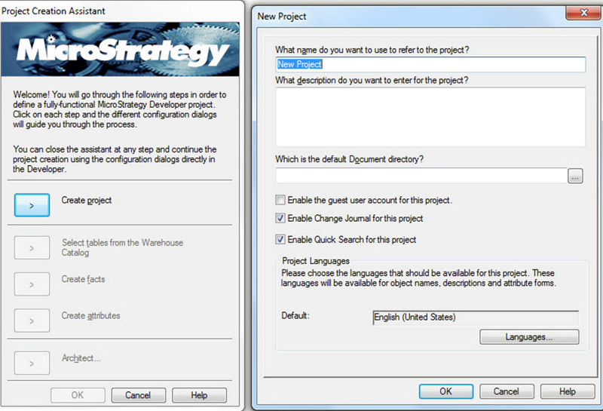

Project Creation Assistant

1. The Project is created and the user can continue using the wizard, or exit by clicking OK and follow the project configuration and objects creation manually.
2. For this exercise, we will do an additional step that will help to associate a database (data warehouse) to our newly created project. Click on “Select tables from the Warehouse Catalog” This action will prompt the selection of a Database Instance, shown as follows:

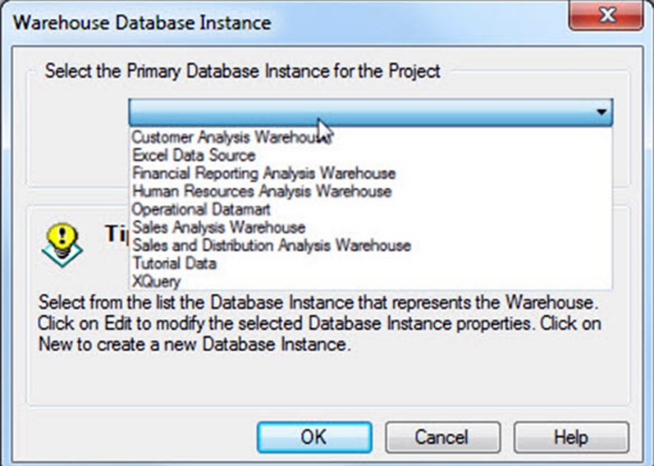

Associating a database to our newly created project

1. Select Tutorial Data. A MicroStrategy Database Instance is a configuration object used to connect to a database. We will learn later in [Chapter 7](https://cdp.packtpub.com/microstrategy_essentials/wp-admin/post.php?post=25&action=edit#post_30), *Administration – Maintaining and Monitoring Your Project*, how to create them and configure a MicroStrategy Project, pointing it to a data warehouse or data mart. For the sake of this exercise, we will use a previously created Database Instance pointing to a retailer called Tutorial. If you want to see the Microsoft Access database, it is located within the Tutorial Reporting folder (in Windows C:\Program Files (x86)\MicroStrategy\Tutorial Reporting) with the name TUTORIAL_DATA_7200.mdb.

*Unix/Linux installations don't have this Microsoft Access file.*

1. When you click OK, the Warehouse Catalog is opened. We will later explain what this is. For this exercise, just close the window (red X on right corner). Then again click OK on the Project Creation Assistant. You will see a message telling you that it is possible to continue the Project creation without the assistant. Don't click OK again.
2. This finalizes the exercise. You should now see your new Project within the Project Source along with the MicroStrategy Tutorial and Human Resources Analysis Module Projects.

# Your building blocks – Schema Objects

The MicroStrategy Schema Objects are going to be the foundation of any project. These objects serve as building blocks on which other objects will be erected.   
Generally speaking, Schema Objects are mapped to database structures such as tables or columns with a few exceptions in which other Schema Objects are used as part of their components.   
  
Usually, there is only one person at a time creating or modifying Schema Objects. This person is called the project Architect. It is not recommended to have multiple persons modifying Schema Objects since this could lead to metadata inconsistencies and eventually corruption. Once any change has been performed to a schema object, it is necessary to commit this change into the metadata. To do so the Architect must Update Schema.

**Exercise – updating Schema**

It is very important to update the project's Schema every time there is a Schema Object change, addition, or deletion. In this exercise, you will learn how to update the Schema with the following steps:

1. Select the project where the schema will be updated. For this exercise select the MicroStrategy Tutorial project.
2. Open the project by double clicking on it or clicking on the plus symbol on its left.
3. Go to the Schema menu | Update Schema.
4. On the next window, shown as follows, make sure only the first option is selected with Update schema logical information | Update:

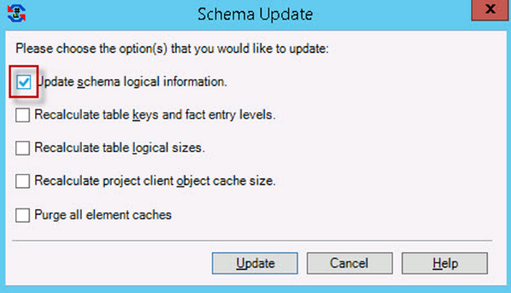

Selecting the Update Schema logical information

The other options are related to other Schema and administrative tasks.

1. This finalizes the exercise.

The schema can be updated at any time, even if no change has been introduced on the Schema Objects (like in the exercise). However, it is mandatory to do so when any schema object has been modified, created, or deleted. Failing to update the schema might result in memory differences with the physical metadata and eventually a metadata corruption.

# The Source – Tables

The first **Schema Object** to be created must be a MicroStrategy Table. The following is a quick reference table for this MicroStrategy Object:

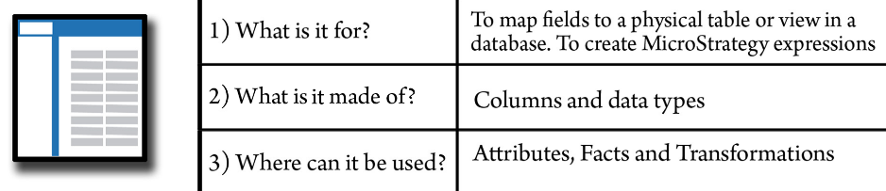

This object is simply the logical representation of a table in the database (data warehouse). MicroStrategy imports into the object definition the table name, structure, columns, and data types. In addition, MicroStrategy assigns a value to the table based on the fields and Attributes mapped to it. It is important to mention that this number doesn't represent a measure of megabytes or number of rows but instead a conceptual value; this is why it is called the **“logical table size”.**   
  
This number is utilized by the MicroStrategy SQL Engine to choose which table should be used for the query when two tables are available to get the same data. MicroStrategy chooses the table with the smaller logical table size to optimize the query. Nevertheless, this number can be manipulated by the project Architect. An example of this scenario would be forcing the MicroStrategy SQL Engine to choose a table with a lower level of detail over a summary table.

# Warehouse Catalog

Tables are created through the MicroStrategy Warehouse Catalog. This window shows on the left pane the physical tables and views available in the warehouse database and on the right pane which of those tables have been created as MicroStrategy Tables. Once a table is moved from left to right, its definition is saved in the MicroStrategy metadata as an object, a logical table, as shown in the following screenshot:

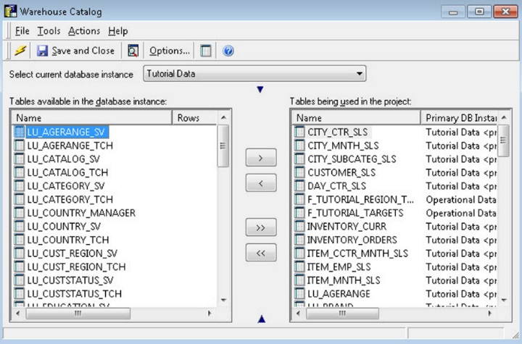

Definition  saved in the MicroStrategy metadata as an object

**Table structure**

Each Table in MicroStrategy has two main views:

* **Logical view**: This view will show which Attributes and Facts are mapped to the table along with information about keys and logical size.
* **Physical view**: This view shows the columns/fields and associated data type from the actual database table, as shown in the next screenshot:

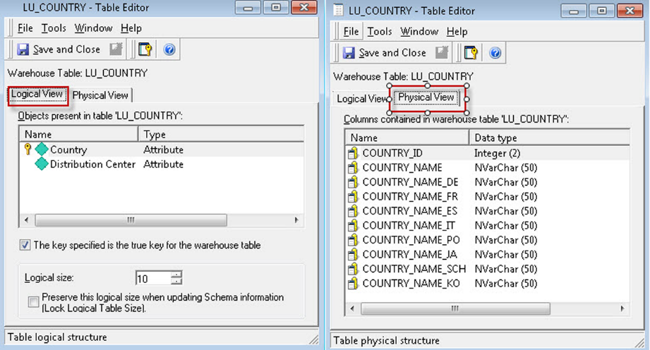

The Logical and Physical view of a table in MicroStrategy

**Exercise – Import a few Tables**

In this exercise you will use the MicroStrategy Warehouse Catalog to import a few Tables.

1. Open your newly created project MicroStrategy Essentials.
2. Access the Warehouse Catalog: Go to menu Schema | Warehouse Catalog.
3. Select current database instance | Tutorial Data. This dropdown will show the connections to different databases in your environment.
4. Select LU_COUNTRY, LU_REGION and LU_CALL_CTR and move them to the right pane, shown as follows:

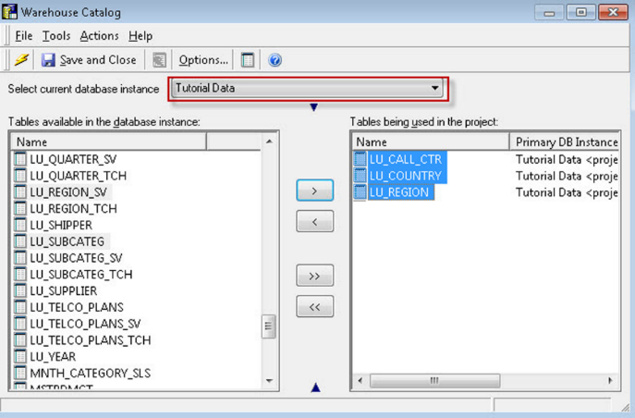

Moving LU_COUNTRY, LU_REGION and LU_CALL_CTR to the right pane

1. Save and Close.
2. Update the Schema.
3. This finalizes the exercise.

**Business raw measures – Facts**

MicroStrategy Facts are objects that represent a business measure stored in a database table. The following is a quick reference table for this MicroStrategy Object:

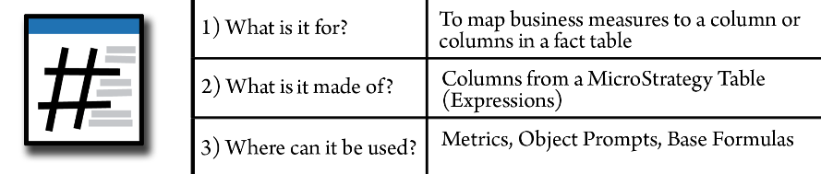

 These measures usually have the following characteristics:

* They are numerical
* They can be aggregated (summed up or operated in some way)

The Facts usually map directly to one or more columns in a Fact table.  
The Fact is defined with a MicroStrategy expression. An expression could be:

* **Base**: an expression which is represented as a single table field
* **Derived**: an expression in which two or more table fields are operated or a function is applied to them

The Fact on its own is meaningless. It needs a context and a rule of aggregation in order to be useful. In the following sections, we will learn about which other MicroStrategy Objects serve this purpose.

**Exercise – creating Facts**

In this exercise you will learn to create Facts. Take the following steps:

1. Open your newly created MicroStrategy Essentials project then import the Table MNTH_CATEGORY_SLS and update the Schema (hint: use the Warehouse Catalog). You can refer to the previous table exercise if you get stuck.
2. Go to the Facts folder (under Schema Objects) and right-click New | Fact.

The Fact Editor has two windows. The inner one is the Fact Expression editor while the outer one is the Fact Editor, shown as follows:

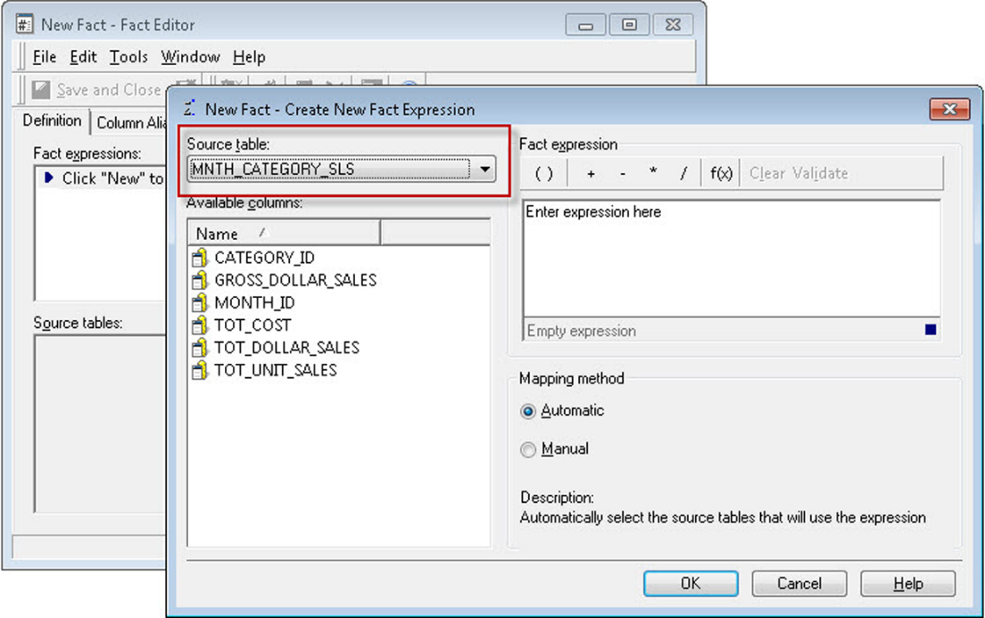

Fact Expression editor ad Fact Editor

1. In the Expression editor, make sure the Source table dropdown shows the MNTH_CATEGORY_SLS table.
2. Double-click on TOT_DOLLAR_SALES | OK. The automatic mapping method will relate this object to any other table in the Project where this specific expression exists.
3. Review your Fact. Check the expression on the upper pane and the related source table(s) on the lower pane, shown as follows:

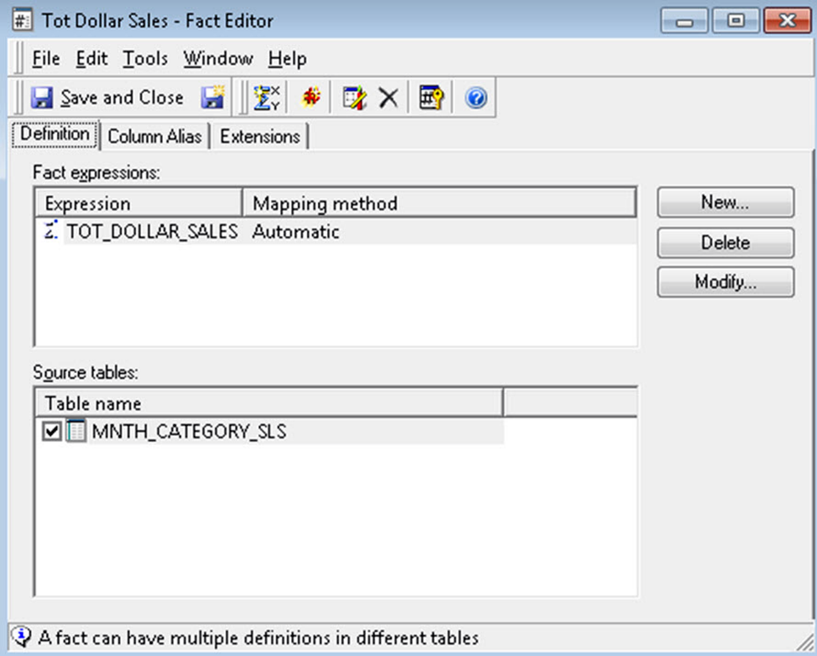

Reviewing your Facts

1. Save and Close on the Fact Editor. Leave the default object name as Tot Dollar Sales.

*You can update the Schema now or wait until you create or modify multiple Schema Objects.*

1. Repeat the above process for the GROSS_DOLLAR_SALES Fact.
2. Update Schema. This finalizes the exercise.

*Note: MicroStrategy Facts can't be used directly on Reports. It is necessary to create an Application Object on top (Metrics) that will describe the aggregation function and aggregation level for the business measure.*

**Business context – Attributes**

MicroStrategy Attributes are objects which represent a business context, or dimension. The following is a quick reference table for this MicroStrategy Object:

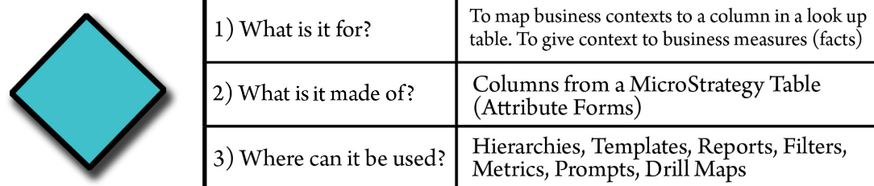

 The Attributes will provide the level in which a given Fact is stored in the database and which that Fact can be aggregated to. An Attribute could be mapped to one or more columns in a database table. These tables are commonly referred to as lookup tables or dimension tables. However, it could be mapped to any type of table such as Fact tables.

As opposed to the Facts, the Attributes are not directly built from MicroStrategy but from one or more MicroStrategy **Attribute Forms**. The following diagram helps you to understand how an Attribute is defined in MicroStrategy:

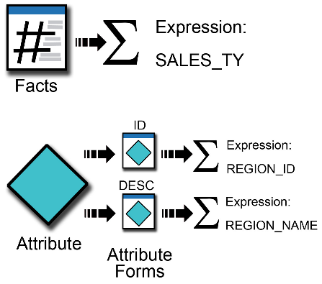

An Attribute form is a characteristic of the same business context. From the previous diagram, we can see that there is an Attribute that has two forms: one is an identification number, and the other is a description. Both columns define the same business context which could be the business region.   
An Attribute must have at least one form (ID) and could have as many other characteristics as required. For example, the customer Attribute could have the following forms:

* ID
* First name
* Last name
* Suffix
* Prefix
* Nickname

# Understanding the Attribute Editor

As opposed to the Fact Editor where there are only two nested windows, the Attribute Editor has three (listed from the inner to the outer window): Form Expression Editor, Attribute Form Editor and Attribute Editor, shown as follows:

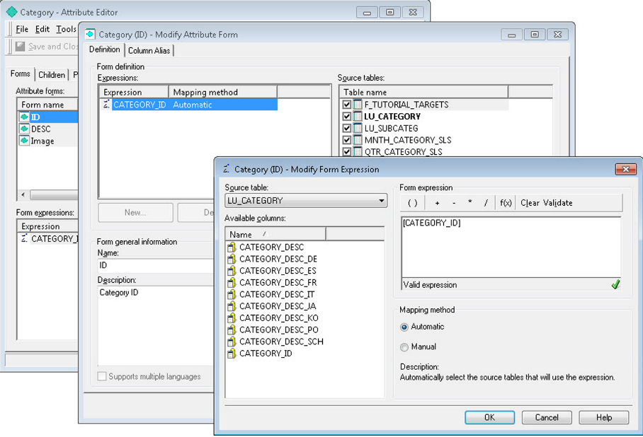

Three windows of the Attribute Editor

The inner most window, the Form Expression Editor, is where you define each Attribute form's expression in a similar way as the Fact's expressions are defined. First, select a MicroStrategy Table as the source. The expression for a certain Attribute form could reside in one or more tables in the database. If you want to manually associate the tables, choose the Manual mapping method, otherwise the Automatic mapping method will relate the Attribute form expression to any other table in the Project where it exists. In the previous image, the CATEGORY_ID expression comes from the LU_CATEGORY table, and it is automatically mapped to any other table where CATEGORY_ID could be found.

Once the form expression is created**, you must select a lookup table**. The lookup table is a table where MicroStrategy will pull the description for a unique set of business contexts IDs. It is usually called data catalog or dimension table. You can control it in the second-inner window (Attribute Form Editor), which is the lookup table, which shows the tables the form is associated with and other form settings such as data type, alias, and default sorting, as shown in the next screenshot:

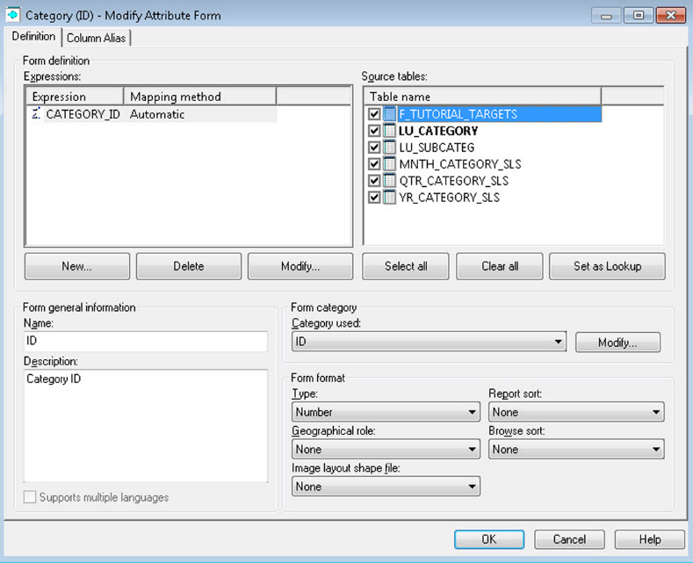

Attribute Form Editor

The next step in the Attribute creation process is to verify the forms created and/or create additional forms. Usually an Attribute has an ID and a DESC (description) form, shown as follows:

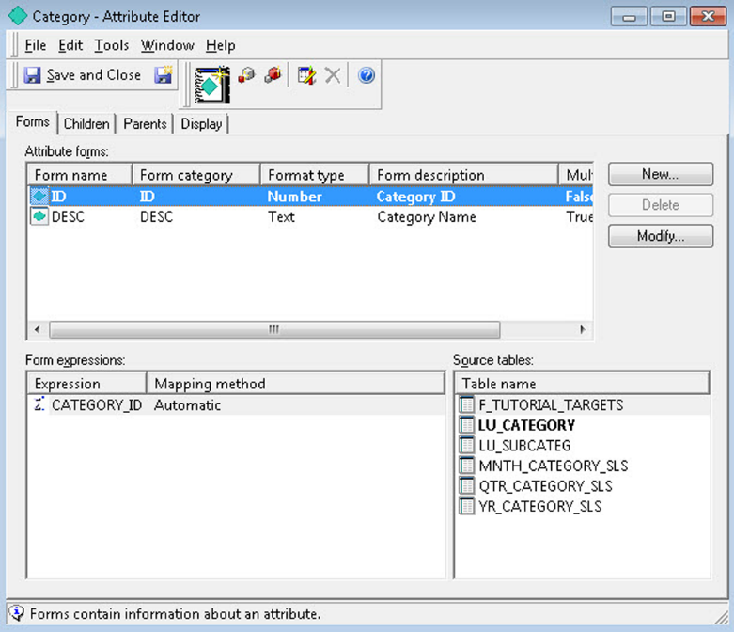

Attribute creation

In the outer most window you will be able to define Attribute Relationships, and see how they relate with other business contexts within the same dimension or Hierarchy. To add a relationship, simply go to the corresponding (children or parents) | Add tab, and establish a relationship type and relationship table, as follows:

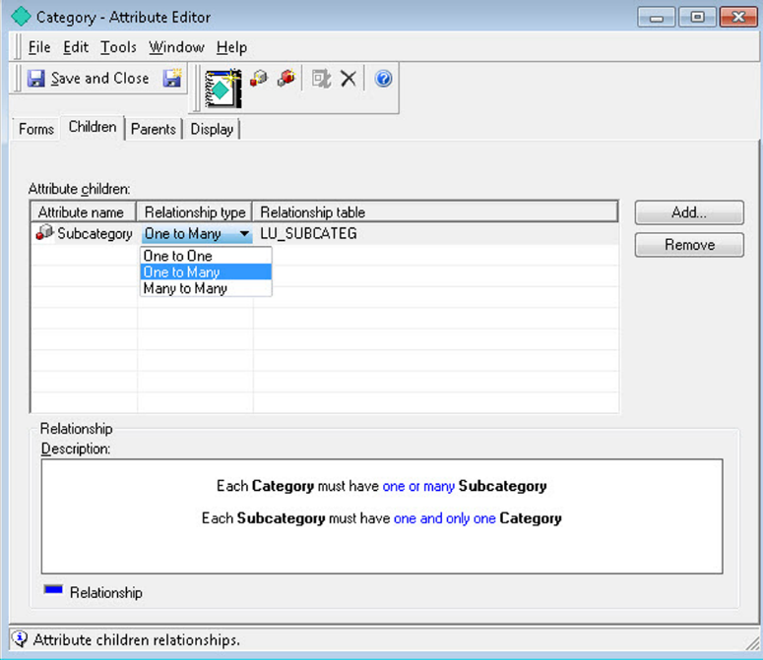

Adding and establishing a relationship type and relationship table

*It is important to make sure the Architect understands the data model and how the different Attributes should be related. If you don't see an Attribute or table candidate related to another, it is likely that the data model doesn't support it.*

**Exercise – creating Attributes**

In this exercise, you will learn to create Attributes. Take the following steps:

1. Open your new MicroStrategy Essentials project and go to the Schema Objects | Attributes folder.
2. Right-click New | Attribute.
3. The Attribute Editor will open the three nested windows. In the innermost, the For Expression must be defined. Select the LU_COUNTRY table.
4. Double-click on the COUNTRY_ID column. Leave Automatic mapping | OK.
5. You should now be on the second window, the Form Editor. Verify that the lookup (in **bold**) table is LU_COUNTRY. Which other table is selected? If you had selected the Manual method, none of the tables would have been selected and you must manually check which should be used.
6. As shown in the following screenshot, verify that the form category is ID and the data type is Number | OK:

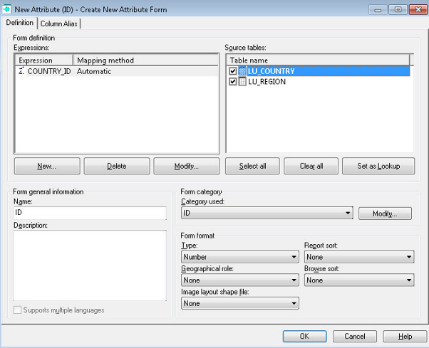

Verifying the form category and data type

1. You should now be on the outermost window. So far only the ID form has been created. You will now add a description for this Attribute. Click on New to add a new Attribute form, shown as follows:

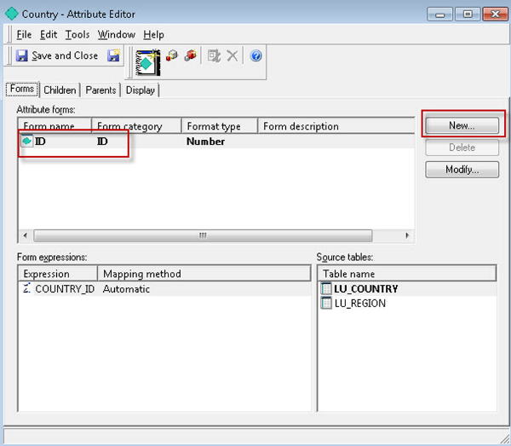

Adding a description for the Attribute

1. Using the same source, the (LU_COUNTRY) table, define an expression for COUNTRY_NAME. Repeat steps 4 to 6, but this time for the text field that will be used as a description for Country. Your Attribute Editor window should show both ID and DESC forms created, shown as follows:

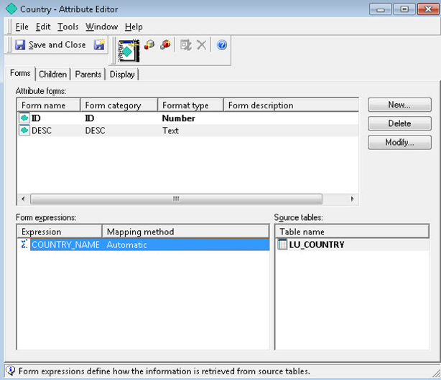

Attribute Editor displaying ID and DESC

1. Save and Close. Leave the default object name as Country | Save.
2. Repeat the process to create a Region Attribute with the following information:
   * **Source table / lookup table**: LU_REGION
   * **Attribute forms**: ID (REGION_ID) and DESC (REGION_NAME)
   * **Parent**: Country

11. To assign the region parent go to the Parents tab | Add | select Country Attribute | OK. The relationship type and table should look like the following:

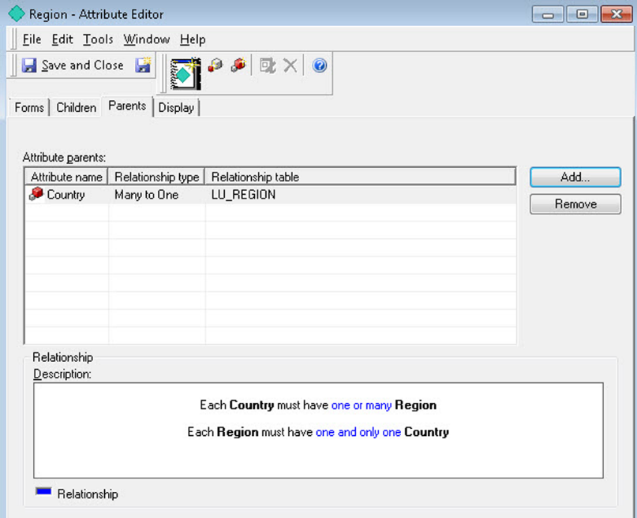

Relationship type and table

1. Save and Close. Leave the default object name as Region | Save.
2. Repeat the process to create a Call Center Attribute with the following information:
   * **Source table / lookup table**: LU_CALL_CTR
   * **Attribute forms**: ID (CALL_CTR_ID) and DESC (CENTER_NAME)
   * **Parent**: Region

14. Save and Close. Leave the default object name as Call Ctr | Save.

1. Update Schema. This finalizes the exercise.

**Grouping business context – Hierarchies**

MicroStrategy Hierarchies are Schema Objects made of Attributes, which serve two main purposes:

* Help to visualize and understand the relationships between the Attributes
* Define paths for users to drill (drill maps and drill paths)

The following is a quick reference table for this MicroStrategy Object:

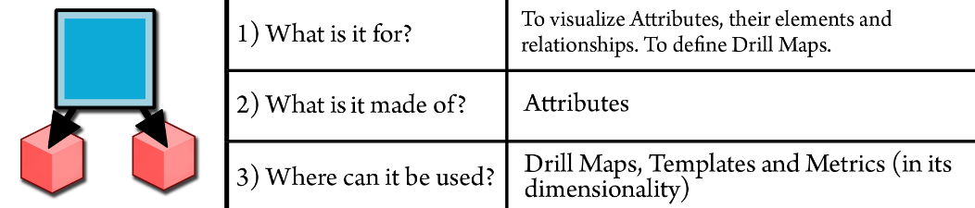

If you navigate to the Data Explorer, you will find the first Hierarchy that is created by default once the first Attribute is saved into the Project—System Hierarchy, as shown in the next screenshot:

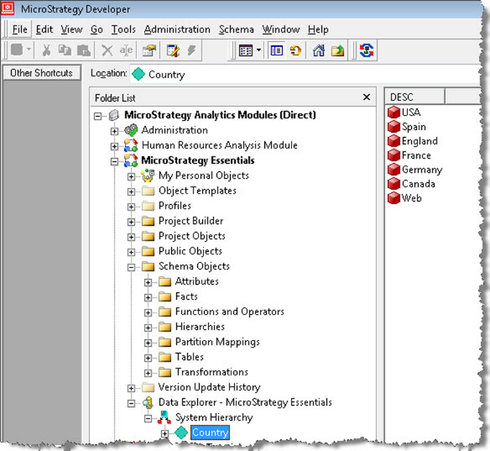

System Hierarchy

The System Hierarchy will show all the Attributes in the project with their relationships and their Attribute elements. The Attribute elements are simply the data inside the lookup tables. It is important to note that the Attribute elements are **not Objects** but data instead.

The Architect can define **user Hierarchies** and make them available for final users as drill paths to perform data discovery and further analysis on Reports. In the next exercise, we will learn how to create a user Hierarchy.

**Exercise – Creating user Hierarchies**

In this exercise you will learn to create Hierarchies.

1. Open your new project MicroStrategy Essentials and go to the Schema Objects | Hierarchies | Data Explorer folder.

*Note: you can save a Hierarchy in any other folder. However, to make the Hierarchy available inside Data Explorer it must be saved in the above location.*

2. Right-click New | Hierarchy.

3. On the Select Objects window, shown as follows, select Call Ctr, Country and Region | OK:

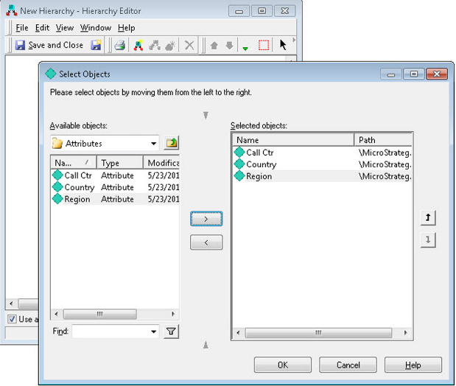

Select Objects window

1. The highest-level Attribute will be selected as **entry point**. In other words, the Attribute with no parents will have a green check mark that indicates a user will be able to drill from it as a starting point. This behavior can be modified by right-clicking the desired Attribute and Set as entry point. Note the following screenshot:

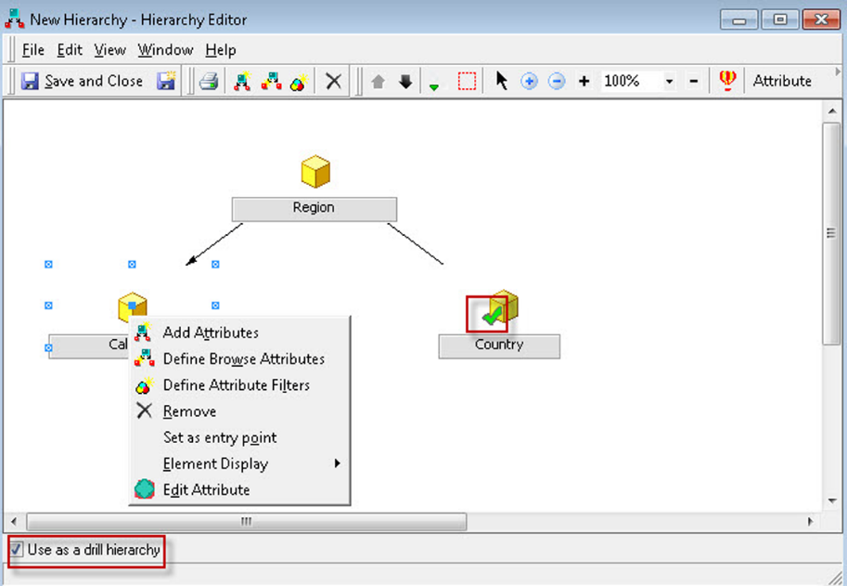

Setting an Attribute as entry point

1. To use this Hierarchy in Reports as a drill path, check Use as drill Hierarchy | Save and Close.
2. Name your Hierarchy as Geography | Save | update schema.
3. Navigate to the Data Explorer (not the folder but the visualization tree instead) and if you don't see your Hierarchy, hit *F5*. Expand your Geography Hierarchy to reveal the Attribute relationships and elements, shown as follows:

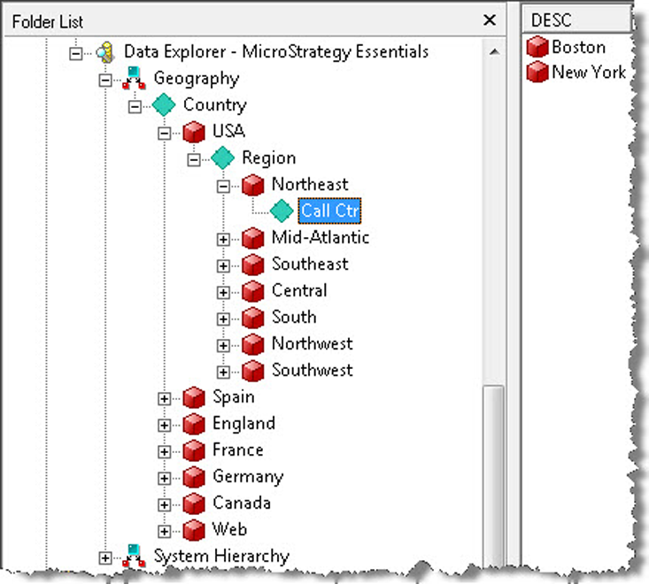

Attribute relationships and elements

1. This finalizes the exercise.

# Comparing data across time – Transformations

Transformations are objects that are used inside Metric definitions (we will cover Metrics in the following chapters) to map a time period to another offset time period. The following is a quick reference table for this MicroStrategy Object:

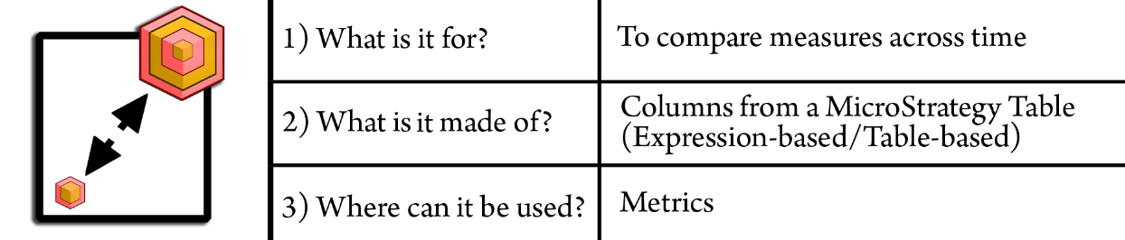

This object will allow users to perform comparisons between different times, such as this month versus last month, or this year versus last year.

Transformation could be defined using an offset calculation or formula. For example, YEAR -1 to define last year. However, due to the complexity and dynamism of some calendars such as 4-5-4 calendars, it is recommended to use database tables (Transformation tables) to define how a current time Attribute should be mapped.

You can check how table-based Transformations are created by navigating to MicroStrategy Tutorial project | Schema Objects | Transformations and opening any transformation. For example, the Previous Transformation, shown as follows:

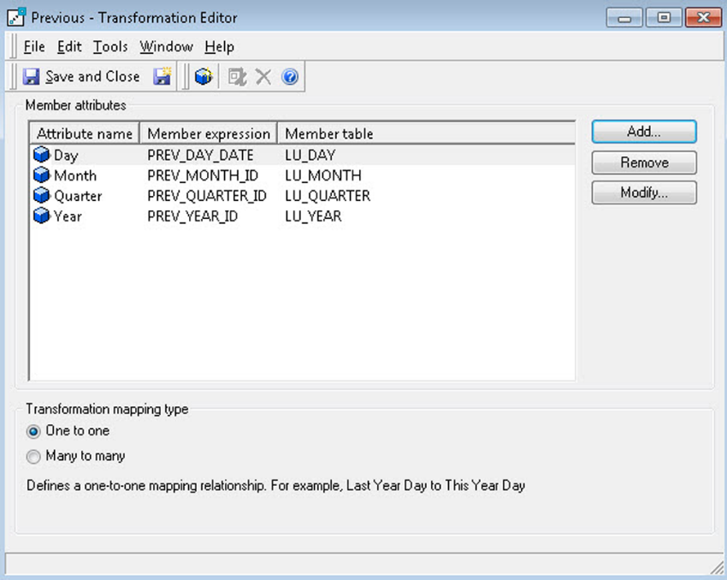

Checking table-based Transformations

You can see this Transformation has four Attribute members, each one with its corresponding transformation expression and where this expression is pulled from. When this Transformation is added to a Metric (such as sales), it will calculate the aggregation not to the actual time but instead using the Transformation expression.

**Summary**

At the end of this chapter, you should be able to differentiate the three main object types or categories. You should be familiar with the MicroStrategy Developer interface and default Project structure. At this point you should understand and be able to create the following objects:

**Configuration Objects**:

* Project

**Schema Objects**:

* Table
* Fact
* Attribute
* Hierarchy
* Transformation

In the next chapter, we will create and manipulate our first Report but not before understanding some of its component objects: Templates, Filters, and Metrics.

**Basic Reporting - Building Your First Reports**

After learning about the MicroStrategy Project foundation and the main types of objects, it is time to build your first Report. To accomplish this, it is necessary to learn a few new concepts and some additional objects. This chapter will introduce you to the Public Objects, also known as Application Objects. Then we will build some basic Public Objects, including a Report, Filters, and Metrics. We will end this chapter with some fundamental Report manipulations.

The following topics will be covered in this chapter:

* Understanding MicroStrategy Public Objects
* Explaining MicroStrategy Reports and how to create one
* Explaining MicroStrategy Templates and how to create one
* Explaining MicroStrategy Filters and how to create one
* Explaining MicroStrategy Metrics and how to create one
* Performing Report manipulations

# Your analyzing blocks – Public Objects

The MicroStrategy Public Objects are also known as Application Objects. As the name suggests, these objects are used by the users and analysts (Public), and their main purpose is to create analytic and BI applications. There is usually more than one developer maintaining this type of object. Therefore, unlike the Schema Objects, it is not necessary to perform an update schema after any Public Object creation or change.

Some Public Objects are built upon the foundation that the Schema Objects have created. In other words, some have, as components, other Schema Objects such as Attributes or Facts. There are also other Public objects that are built entirely using other Public Objects or a mix of these and Schema Objects. The following diagram depicts both Schema and Public Objects and which objects are used to build them:

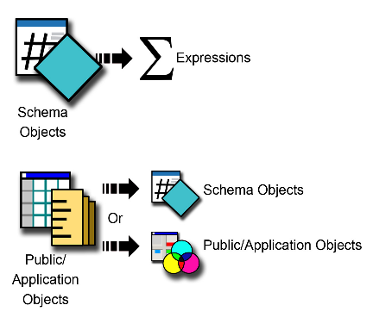

# Your main analysis tool – Reports

All Public / Application Objects serve one purpose: to build Reports or Documents (Dashboards) that will allow users to perform analysis. Reports are the primordial analytical assets in any organization.

The following is a quick reference table for this MicroStrategy Object:

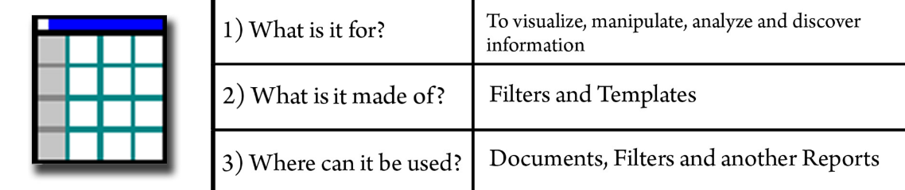

MicroStrategy Reports are Application Objects that serve the purpose of allowing final users to visualize, analyze, manipulate, and discover information and trends.

Reports are made of two main components:

* one Template and
* one or more Filters.

Creating a MicroStrategy Report is a fairly simple task. It just requires combining a Template with a Filter. We will learn in the following sections that the majority of time spent designing a Report is actually time that the developer requires to build the underlying objects such as Filters, Metrics, and Templates.

**Understanding the Report Editor**

The Report Editor has three main sections. Other sections not visible can be accessed via the View menu.

Refer to the following screenshot for each section:

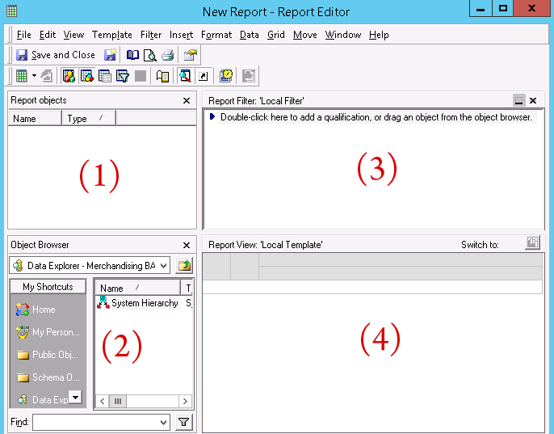

1. The upper-left area is called the Report objects window. It lists all objects that are part of the Report definition. If MicroStrategy OLAP Services are licensed, then developers can create Reports in which part of its definition can be hidden in the Reports Objects while other objects are shown in the Report View (where the Local Template is). This is helpful to create different views from the same Report.
2. The lower left section is the Object Browser. It provides a tree-like structure navigation similar to Microsoft Explorer and some shortcuts to access the most-used folders. This section will be utilized to find the Report components; either drag or double click them into one of the two above areas.
3. The upper-right section is the Report Filter area, where the Filters are added.
4. The lower-right area is the Report View, where the Report Template resides.

**Exercise – create your first Report**

In this exercise, you will learn to create a Report using preexisting objects on the Tutorial Project. Later on, you will learn to create the underlying objects to build a Report from scratch. Take the following steps:

1. In MicroStrategy Developer, log in to the MicroStrategy Analytics Modules Project Source.
2. Open the MicroStrategy Tutorial Project.
3. Browse to the folder MicroStrategy Tutorial | Public Objects | Reports.
4. Create a subfolder named My Exercises.

*You create a folder the same way you do in the Microsoft Explorer.*

1. Once inside the My Exercises folder, right-click | New | Report. A New Grid window will pop up. Leave the default Blank Report option | OK. The Report Editor will open.
2. In the Object Browser section (if it is not visible go to View menu | Object Browser), click on the Public Objects shortcut. Alternatively, you can also use the dropdown to navigate to the desired location, then browse to the Templates. Select the Time Analysis Template and drag and drop it to the Template section.
3. Use the Object Browser to locate the following path: Public Objects | Filters | Miscellaneous Filters. Then drag and drop the TV & Video Filter into the Report Filter section.
4. Click on the Grid view icon located on the Report Editor tool bar, shown as follows. The Report will now execute:

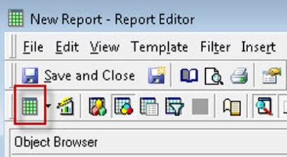

Grid view icon to execute the Report

1. Your newly created Report should look like this one:

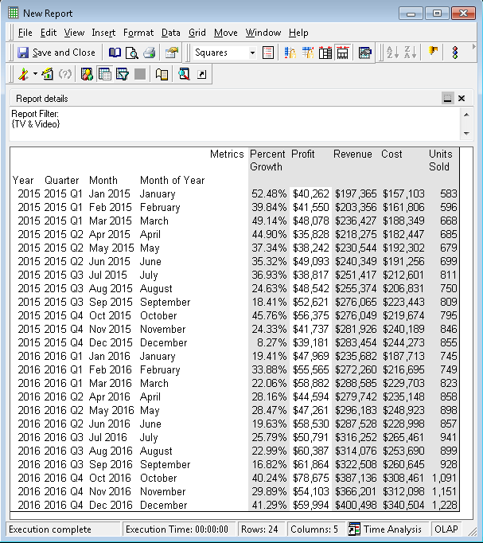

1. Click on the Save and Close button; name it My First Report.
2. A window will pop up with more options; select Retain the shortcut to the template. I will explain the difference in the next section. If a dependency warning window pops up, click OK.
3. This finalizes the exercise.

# Understanding Local Objects versus External Objects

MicroStrategy is an object-oriented application in which objects can be considered as building blocks. These blocks can be reused to build larger blocks, and so on. Also, they can be used to build not only one but several other larger structures, implying that some objects can be shared and reused.

In other words, one MicroStrategy Object can be used in multiple other objects at the same time. However in some scenarios, an object can be created inside another one as a local object. This is also referred to as an embedded object and only exists inside the object in which it was created. Therefore, local or embedded objects are not available for use with any other object definition.

In the previous exercise, we created a Report using an existing Filter and an existing Template. These two objects were originally designed and created as external objects that could be reutilized into another larger object's definition. In the following exercises, we will understand the implications of using external objects or local objects when designing applications.

**Exercise – searching for components and dependents**

In this exercise, you will use the search window to find an object's components and dependents. Take the following steps:

* Log in to the MicroStrategy Analytics Modules Project Source.
* Open the MicroStrategy Tutorial Project.
* Navigate to the My Exercises folder. *It is inside the Reports folder in Public Objects.*
* Locate My First Report | right-click | Search for Components.
* You should see the following results (the Filter and Template used on our previous exercise):

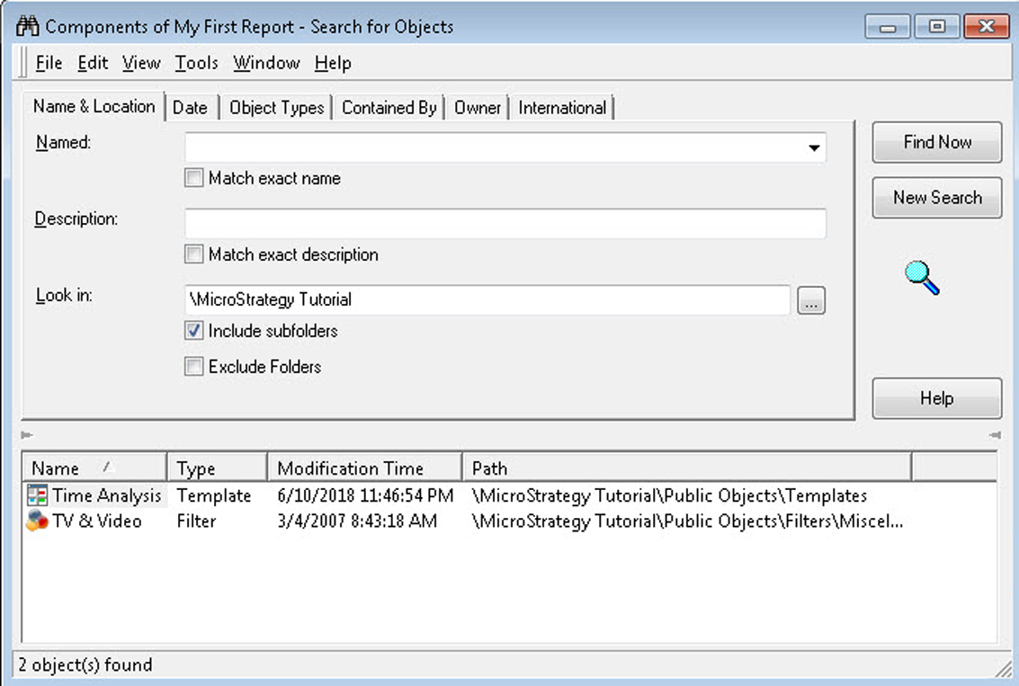

Screen displayed when you click on search for components

* Navigate to the Templates folder. *It is inside the Public Objects folder.*
* Select the Time Analysis template | right-click | Search for Dependents.
* You should see the following results (all Objects in which the Time Analysis template is used):

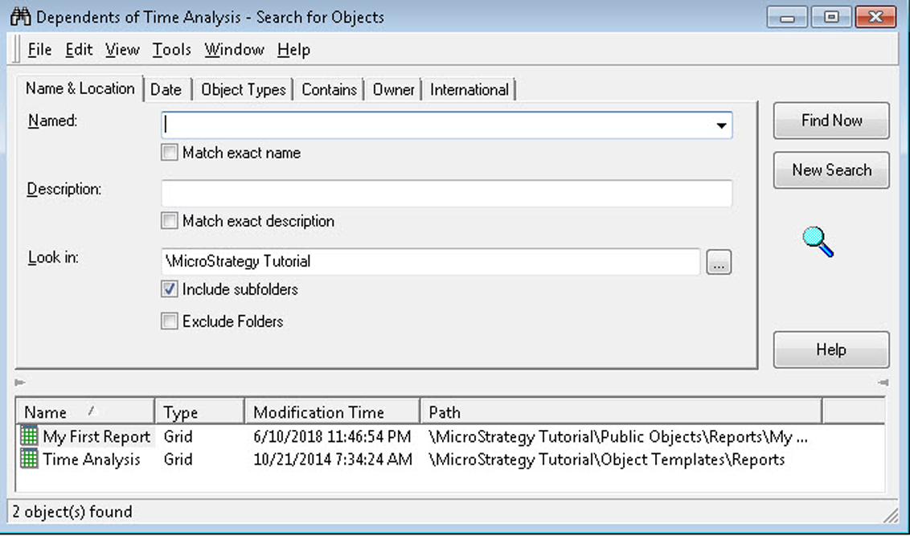

Screen displayed when you click on search for Dependents

* Go back to the Templates folder | double-click the Time Analysis template or right-click | Edit.
* The Template editor will open. On the Object Browser navigate to the Schema Objects | Attributes | Products folder | double-click Subcategory. This action will add the subcategory Attribute to the Time Analysis Template.

*Note that if you save the Template any object dependent on it will be impacted. This is one of the implications of using***external***objects that are linked or referenced by other ones.*

* Save and Close. You will see a window with precisely this warning, detailing which other objects are affected by this change. Click OK.
* Go back to the | Reports | My Exercises location and double-click My First Report to execute it. You should see in your Report the Subcategory added to its template with only TV and video results (and limit established in the Filter). This finalizes the exercise. Your results should resemble the following screenshot:

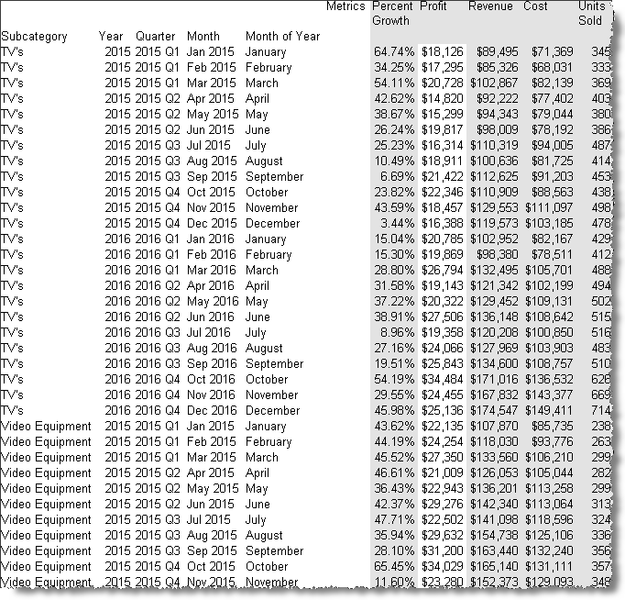

# Reusing your report designs – Templates

In the previous section, you learned how to create a Report and that its definition is made of one Template and one or more Filters.

The following is a quick reference table for MicroStrategy Templates:

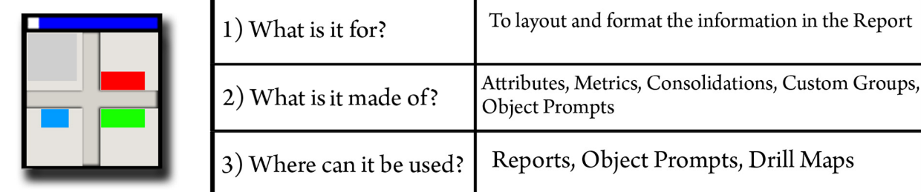

The Template is an Application Object that organizes the information in a certain way (provides a layout) with a specific formatting (colors, fonts, numbers, percentages, and so on) within the Report. Most of the time, Templates are created locally to the Report (embedded), but if the developer wants to reuse a Template, it can be created externally.

The two most common objects used to build Templates are Attributes, which provide the business context, and the Metrics, which provide the aggregation and the business measure. However, we will see in subsequent chapters that other more advanced objects could also be used, such as Prompts and Custom Groups.

*The Template will determine the*SELECT*/*FROM*clause in the SQL that MicroStrategy sends to the database, whereas the Attribute IDs determine the GROUP BY.*

**Limiting your data – Filters**

Filters are versatile Application Objects that limit the amount of information a Report shows in its Template.

The following is a quick reference table for this MicroStrategy Object:

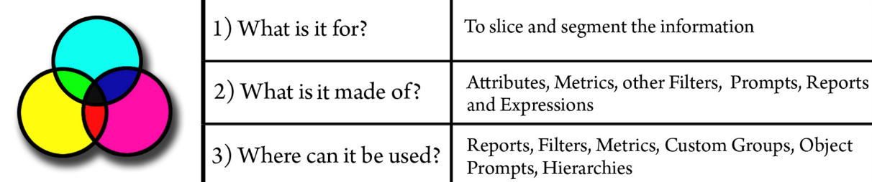

There are different types of Filters depending on what are they made of and where they can be used. These are the main types of Filters:

* Filters from Attributes
* Filters from Metrics
* Filters from Reports

*The Report Filter will determine the WHERE clause in the SQL that MicroStrategy sends to the database.*

**Filters from Attributes**

To create a Filter that limits the information based on an Attribute, simply drag and drop the Attribute to the Filter editor. There are three subtypes of Filters from Attributes:

* **Qualifying on an Attribute form**: Allows the developer to control the column or field from the Attribute (Attribute form such as ID or DESC) and the operator (<, >, <>, =, CONTAINS, in list, not in list, and so on) used in the WHERE clause.
* **Qualifying on a Date Attribute**: If the Attribute form is a date data type, MicroStrategy offers dynamic date-filtering options. That is, the ability to limit and offset data depending on the current date. With these options, developers can create Filters such as yesterday, a week ago, last month, last Sunday, the first day of the month, and so on.
* **Qualifying on an Attribute Element**: The developer visually selects which Attribute Element(s) to include or exclude in the WHERE clause. There are only two operators available for this type of qualification: in list and not in list.

**Filters from Metrics**

To create a Filter that limits the information based on a Metric, drag and drop the Metric to the Filter editor. There are three subtypes of Filters from Metrics:

* **Metric value**: Limits the information based on a value and an operator. Controls the HAVING clause in the SQL.
* **Rank**: Limits the information based on a ranking analytical function, such as top or bottom. It is handled not by SQL but by the Intelligence Server Analytical Engine.
* **Percent**: Limits the information based on a percent and a function such as top or bottom. It is handled not by SQL but by the Intelligence Server Analytical Engine.

# Filters from Reports

You can use a report to create a Filter, then use it on another Report. This design will generate an additional SQL pass in which a TEMPORARY table is generated with the inner Report condition. To create a filter based on a report, drag and drop the Filter to the Filter editor.

**Exercise – creating some Filters**

In this exercise you will learn to create different types of Filters. Take the following steps:

1. Open the MicroStrategy Tutorial Project | navigate to My Exercises folder.
2. For this exercise, we will create a new Report. Right-click | New | Report.
3. Add to the Report's local Template the following objects: Region and Call Center Attributes (location: Schema Objects/Attributes/Geography); Revenue and Cost Metrics (location: Public Objects/Metrics/Sales Metrics).
4. Execute the Report. You should see the following results:

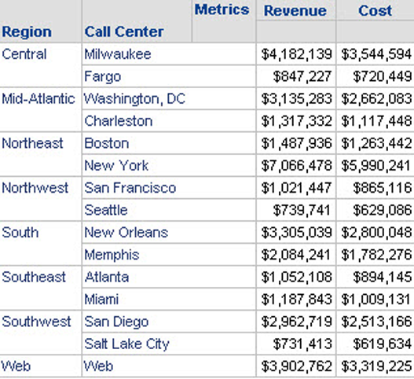

Screen displayed after executing the Report

1. Click on the Design View to access the Report Editor, as shown in the following screenshot:

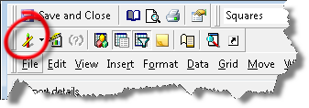

Design View

*It is located below the Save and Close button. The icon is like a red candle.*

1. You will now create a Filter based on an Attribute. In the Object Browser locate the Region Attribute | drag and drop it to the local Filter section of the Report. Select to qualify on the Region description (DESC) and the Contains operator. In the Value box write down North | and click OK as shown in the next screenshot:

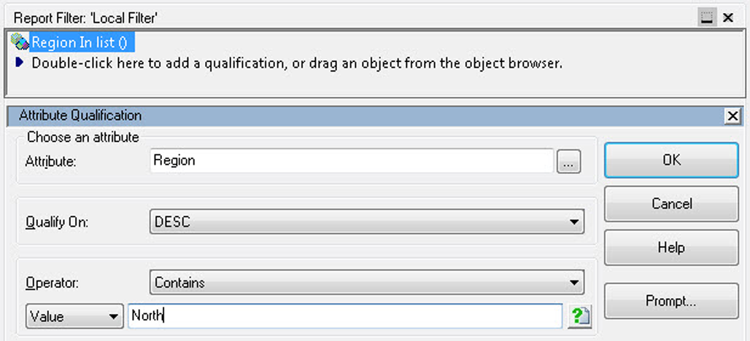

Creating a Filter based on an Attribute

1. Execute the Report. You should see only two regions: Northeast and Northwest | Save and Close | name it Regional Revenue and Cost.

*Test your knowledge: are the Template and Filters from the above exercise external or local?  
Can you reuse them in another Report?  
The answers are, they are local objects embedded into the Report definition, and they can't be shared across other objects.*

1. Right-click the newly created Regional Revenue and Cost Report | Edit.
2. Double-click the Region (DESC) Contains North local Filter | change to qualify on Elements | Add. You will notice a list of regions with a red cube. These are the regions' Attribute elements, in other words, the data stored on the region lookup table.
3. Select Central and South and move them to the right side (you can also double-click them) | click OK to close the Attribute element selection | click OK to close the Filter Editor.
4. Execute the Report. You should see only two regions: Central and South| File menu | Save (or *Ctrl*+ *S*) .
5. Remove the Filter you just created by returning to the Design view | right-click the Report Filter | Remove.
6. Locate the Revenue Metric using the Object Browser | drag and drop it to the Report Local Filter.

*You can also grab it from the Report local Template and drag it up to the Filter section.*

1. Qualify the Metric on Value | operator Greater than | 3000000 as shown in the following screenshot:

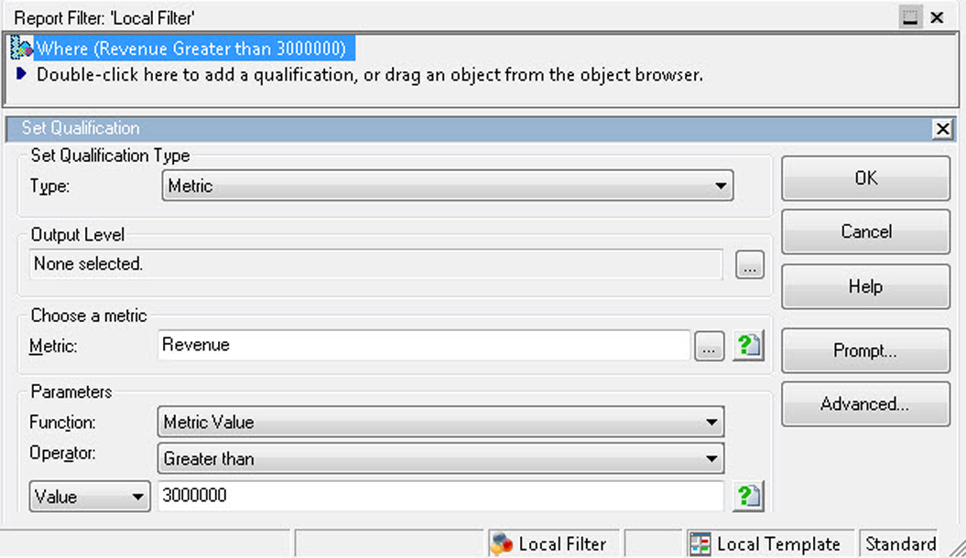

Qualifying the Metric

1. Click OK | execute the Report and verify that only call centers with revenues greater than 3 million are shown.
2. Go back to Design view | edit the Local Filter | change the function from Value to Rank | operator Top | value 3.
3. Execute the Report. You should see the top three call centers by revenue (New York, Milwaukee, and Web) | Save and Close. This finalizes the exercise.

# Business calculations – Metrics

Metrics are Application Objects that serve to aggregate business measures into a certain business context.

The following is a quick reference table for this MicroStrategy Object:

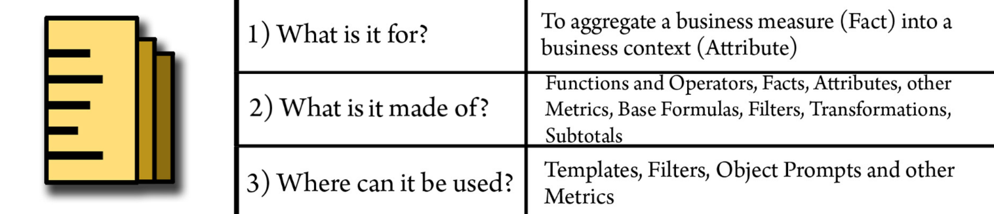

The following diagram represents the logical definition of a Metric:

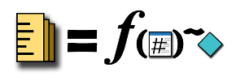

Where a Metric is the result of a function **f** (that can be SUM, COUNT, AVG, and so on) applied to a **Fact** (that can be any raw business measure, like revenue) that is aggregated to a **level** represented by an **Attribute** (that can be any business context or business dimension).

The main difference between Facts and Metrics is that the former is a raw business measure whereas the second is aggregated using a function such as SUM, AVERAGE, and so on, and it is associated to a level or context (an Attribute/hierarchy). *The function can also be applied to an Attribute to generate count-type Metrics.*

**Describing the types of Metrics**

There are three main types of Metrics:

* **Simple Metrics**: These Metrics follow the previous definition. Thus, they are built upon the aggregation of a Fact.
* **Compound Metrics**: These are metrics that result from the operation of two or more Metrics. For example, a percentage change Metric that is defined by dividing the delta of two Metrics, for example, **M2**-**M1** by one of the numerators: (**M2**-**M1**)/**M2.**
* **Derived Metrics**: These Metrics can't be created independently or externally like the other two types. Derived Metrics can only be created locally in the Report definition, and the calculations are performed without the use of SQL (by the Intelligence Server Analytical Engine).

# Defining the report level

Before starting to build Metrics, it is important to understand the Report level in MicroStrategy. Let's use one of the Reports built in the previous exercises, as shown in the next screenshot:

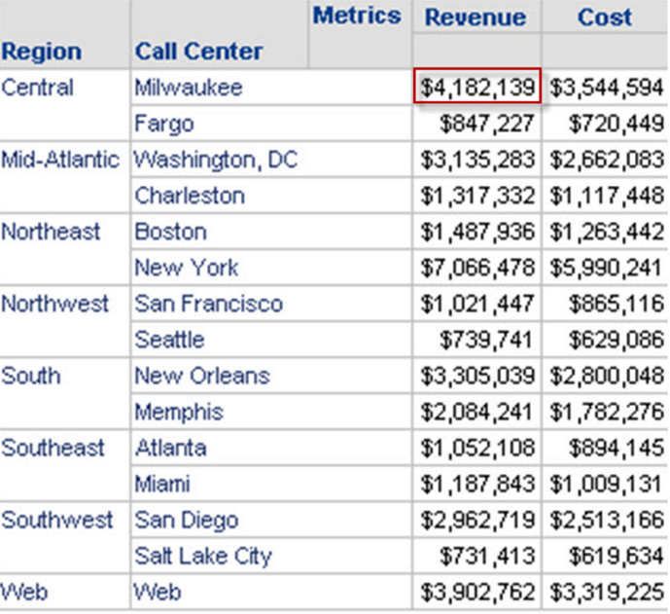

Displaying Revenue, Cost Metrics, and Call Center in a Report

The preceding Report shows revenue and cost Metrics and two Attributes—region and call center. When a user reads the Report it could be understood that either the revenue shown is for a call center or for a region. Due to the layout of the information, it is intuitive that the revenue, for example 4,182,139, is for the Milwaukee call center, which happens to be part of the central region. This is what we call a **Report level**.

The Report level can be defined as the **lowest grain** (or business level of aggregation) shown in a Report template. The lowest grain can be from one or more hierarchies or dimensions. For example, if I add the year and month Attributes, the Report will look as follows:

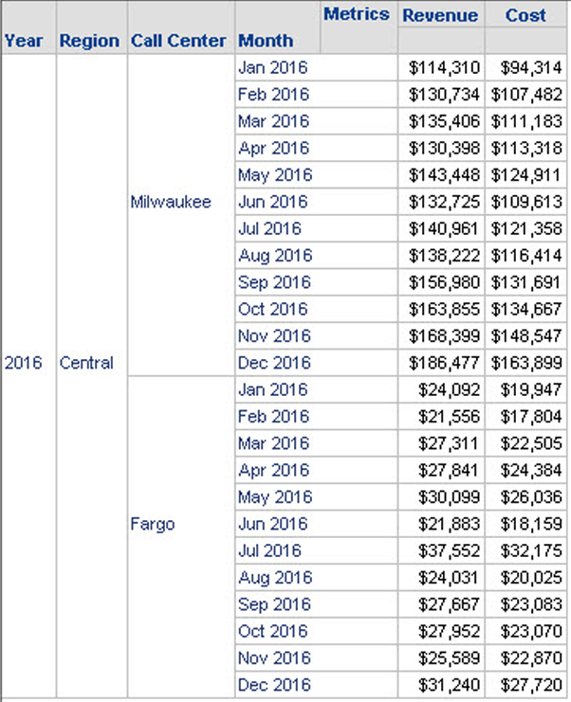

Report with the year and month Attributes

Can you identify the Report level? It would be both month and call center. This means that, by default, the Metrics will be calculated at those two levels—the revenue 114,310 is for Milwaukee and January 2016.

*The level in which a Metric calculates or aggregates the information is also referred to as dimensionality.*

**Understanding the Metric editor and components**

The Metric editor features some familiar sections such as the Object Browser. It has two tabs, one named Formula and one Subtotals / Aggregation as shown in the next screenshot:

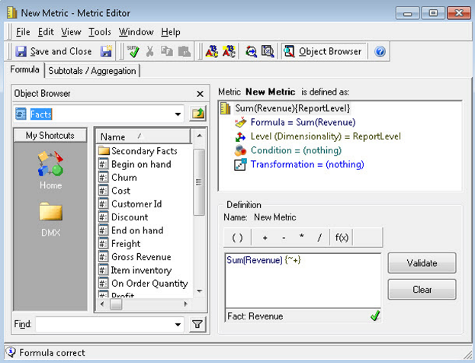Displaying the two tabs, Formula and Subtotals/Aggregation

In the Formula tab, the developer will define the Metric. If the Metric is created using a Fact, it is a simple Metric. The Metric editor will display four components:

* **Formula**: This is the f function and the Fact (it can also be an Attribute but with an f function that could be applied to a string, such as count).
* **Level (dimensionality):** By default the Metric will aggregate at the Report level. This behavior can be modified in this section so that the Metric can be calculated at a higher or different level. This is particularly useful when creating percentage contribution Metrics. To change the dimensionality of a Metric, browse to locate the Attribute(s) into which the Metric will be aggregated.
* **Condition**: To add a Filter to a Metric, use this section. The Filter condition can be added either to the one in the Report definition or treated separately; this is controlled in the condition section of the Metric.
* **Transformation**: In this section, a Transformation is added to a Metric so that it calculates at the time Attribute defined in it.

**Exercise – creating some Metrics**

In this exercise you will learn to create Metrics. Take the following steps:

1. Open the MicroStrategy Tutorial Project | navigate to My Exercises folder.
2. Right click | New | Metric.
3. By default the Object Browser will show the Facts folder. Double click on the Revenue Fact.

*Notice that by default the aggregation is Sum; you can change this function by any other available. Browse to this location to check which other functions exist in MicroStrategy: Schema Objects | Functions and Operators. You can also click on the f(x) button on the metric expression window.*

1. Leave the other components with the default behavior (Dimensionality=Report Level, Condition=Nothing, Transformation=Nothing) | Save and Close | name it Sales.
2. Repeat the above steps to create a new metric, but now go to Dimensionality | browse to the Geography folder | double-click Region. You should see that the Attribute is added to the Level (Dimensionality) as follows:

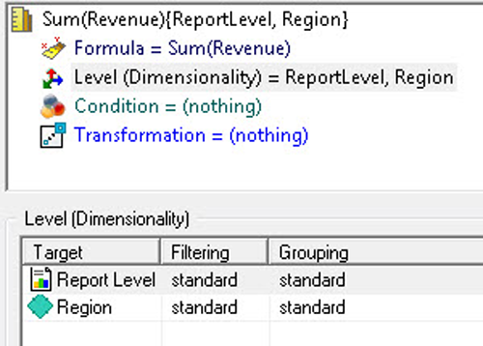

Adding the Attribute to the Level (Dimensionality)

1. Save and Close | name it Regional Sales.
2. Repeat the process once again to create a third Metric but keep the dimensionality at the Report level and now go to the Transformation component | browse the Transformations folder and locate Last Year's | double-click. You should see that the Transformation is added to the Metric.
3. Save and Close | name it Last Year Sales.
4. Execute the Regional Revenue and Cost Report you created in the previous section.
5. Add the Sales and Regional Sales Metrics. It should look like this:

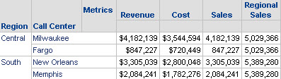

Adding Sales and Regional Sales Metrics to the Report

*Notice that the sales Metric is the same as the preexisting Revenue (it is just formatted with the $ symbol) while the regional sales Metric is the aggregation of sales for all call centers in the region.*

1. Go to the Design View and remove Call Center, Revenue, Cost and Regional Sales.

*You can right-click | Remove from Report or drag and drop the undesired object to the Object Browser.*

1. The Report should have only region and sales. Browse the Attributes and locate Year within the Time folder | add it to the Report's template.
2. Locate the Last Year Sales Metric created above | execute the Report. It should look like this:

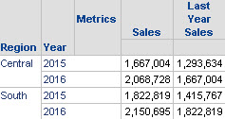

Displaying Last Year Sales Metric

*Notice that the Last Year Sales Metric shows what the revenue was for the prior year. You can remove the Metric to validate that, indeed, the value shown for 2015 corresponds to the 2014 revenue.*

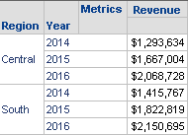

Displaying Revenue

1. Close without saving the Report. This finalizes the exercise.

# Performing Report manipulations

This section of the book will guide you through the main Report manipulations in a cookbook-exercise style.

*Manipulations (with the exception of drilling) are performed in memory and don't generate a new SQL. Therefore, the Report won't re-execute as a result of performing them.*

# Manipulation – Autostyle format

**Objective/usefulness**: To change a Report's color scheme, font types, alignment, and so on. Proceed as follows:

Execute My First Report | Grid menu | AutoStyle Selected |Agent. Your Report should turn blue and gray. Try a few different AutoStyles.

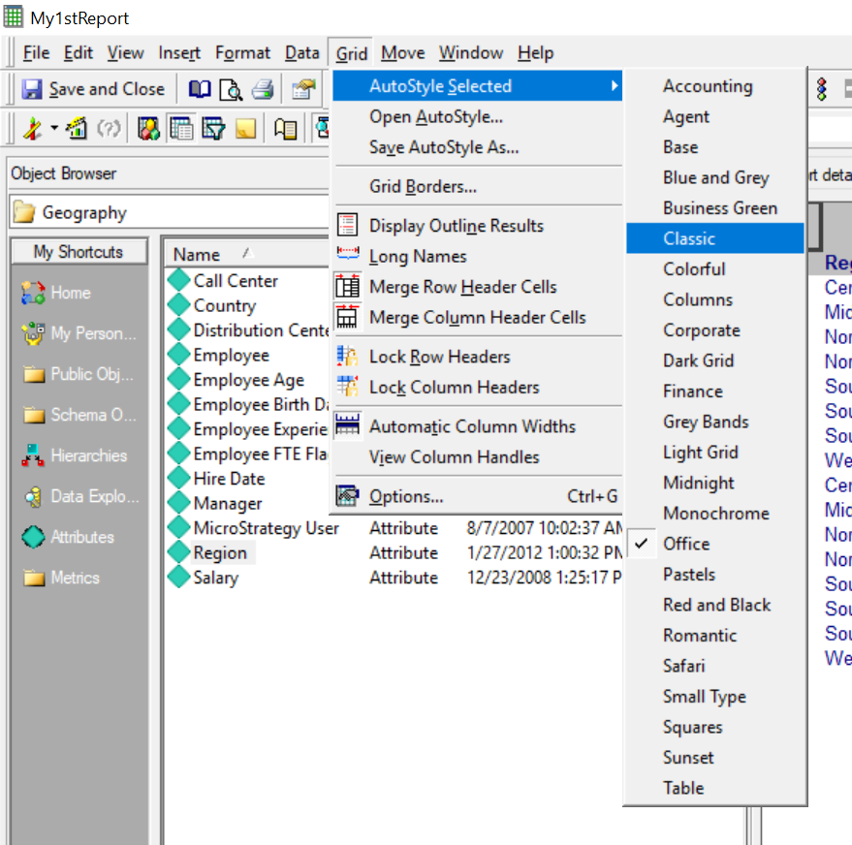

# Manipulation – Grand total

**Objective/usefulness**: To provide summation of Metrics in the Report at the highest-possible level. Proceed as follows:

With the Report executed, press F11 | scroll to the bottom of the Report. You should see a grand total | press F11 again to remove it.

**Manipulation – Subtotal**

**Objective/usefulness**: To provide summation of Metrics in the Report at different aggregation levels. Proceed as follows:

1. Open the Data menu | Subtotals.
2. Select Total | then open the Display Options tab, shown as follows:

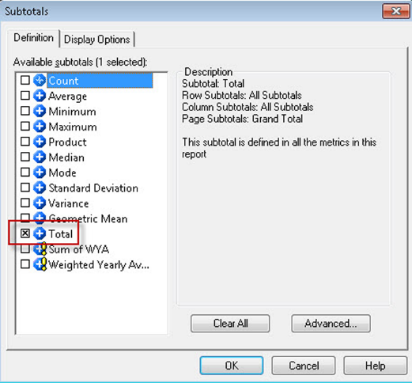

Display Options tab

1. Select the Top of each level in the positions by row | OK. You should see subtotals across all rows. You can control which subtotals to show through the Advanced button within the subtotals window.
2. Press *F11* to keep only the grand total.

**Manipulation – Pivoting**

**Objective/usefulness**: To change the order and layout of columns (Metrics and Attributes) in the Report's template.

* 1. In the Report template, drag and drop the Month header to the far left. Notice how the grid's data gets rearranged accordingly.
  2. Now we are going to arrange the grid in a cross-tab style | then drag and drop the Subcategory header on top of the Metrics header. You can also right-click | Move and select where the field will be pivoted. In this example, it would be To Columns, as shown in the next screenshot:

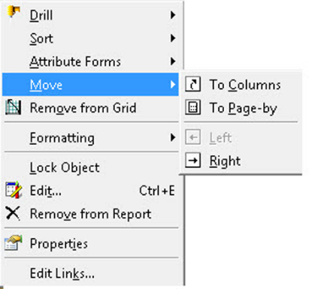

Selecting To Columns option

**Manipulation – Page-by**

**Objective/usefulness**: To provide a dropdown that slices the data at certain Attribute level. Proceed as follows:

1. Open the View menu | Page-by.
2. You should see a section above the Report template labeled Drop Page Fields Here | drag and drop the Year header into this field (you can also right-click | Move | to Page-by.
3. Change the dropdown selection of Year to see how the Report's data changes too.

**Manipulation – Sorting**

**Objective/usefulness**: To order one or multiple columns to a certain logic criteria. Proceed as follows:

1. Right-click on the Quarter header | Sort | Descending.
2. Open the Data menu | Advanced Sorting | Add the following | OK.

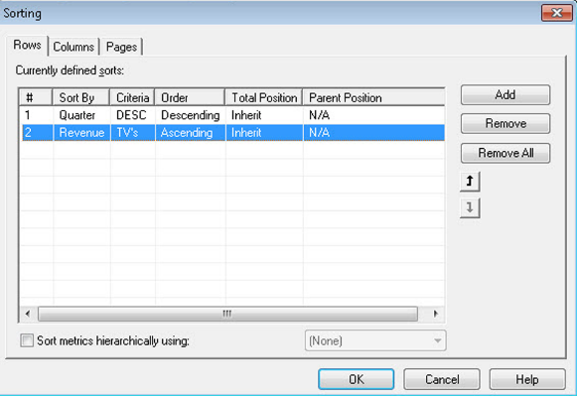

Ordering one or multiple columns to a logic criteria

# Manipulation – Exporting

**Objective/usefulness**: To create a copy of the Report in a third-party format for portability and distribution. Proceed as follows:

Open the Data menu | Export to | MS Excel. Test with other formats such as PDF and text file.

**Manipulation – Graph view**

**Objective/usefulness**: To create a visual representation of the Report's data.

1. Open the View menu | Graph View. Select the default option (vertical bar) | OK. You will see a new tool bar that will allow the developer to switch series by row or column, change the graph type, and format it. Try a few other graph types; these are similar to the ones featured in Microsoft Excel.
2. Switch back to the grid view. View menu | Grid View.

**Manipulation – SQL view**

**Objective/usefulness**: To provide a view of the SQL that MicroStrategy sends to the database. The developer can also use it to troubleshot inconsistencies within the Report's results. Proceed as follows:

1. Open the View menu | SQL View. This is the SQL that MicroStrategy sends to the database.
2. Switch back to the grid view. View menu | Grid View.

**Manipulation – Drilling**

**Objective/usefulness:** To explore higher and lower information levels within the same hierarchy/dimension or across other ones. Proceed as follows:

1. Right click on Subcategory Video Equipment | Drill | Down | Item. as shown in the next screenshot:

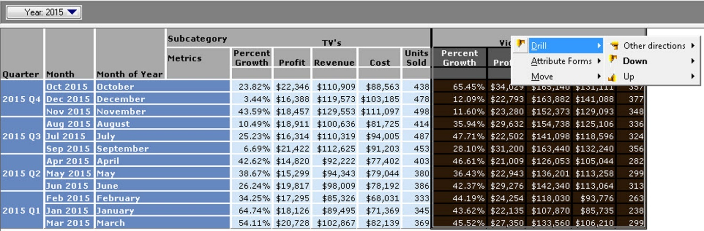

Exploring higher and lower information levels within the same hierarchy/dimension

1. A new Report executes with the item detail for such Subcategory.
2. Pivot the item back to the rows to remove the cross-tab.

**Manipulation – Derived Metrics**

**Objective/usefulness**: Create on-the-fly calculations with the existing Report data. Proceed as follows:

1. Close the Report resulting from the preceding drill operation and return to the parent Report.
2. Right click on the Revenue header | Insert | Percent to Total | Grand Total, as shown in the next screenshot:

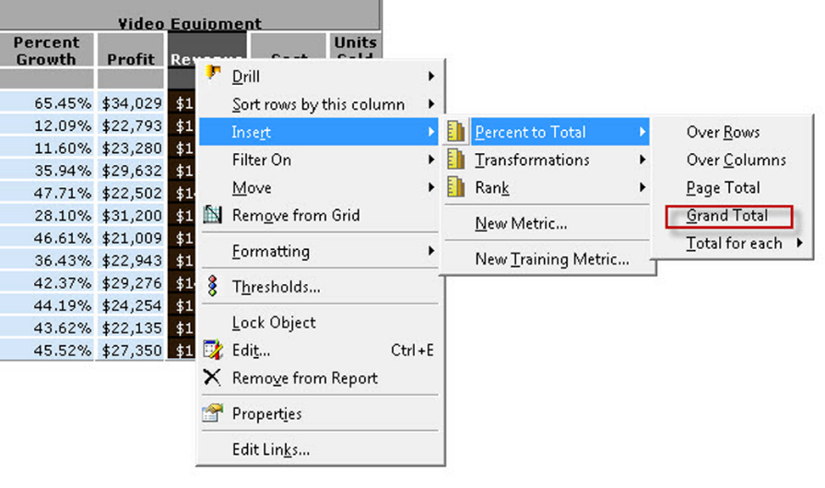

Creating on-the-fly calculations with the existing Report data

*A derived Metric is a Metric local to the Report that won't cause a SQL but instead will be calculated in memory by the Intelligence Server.*

**Manipulation – View Filters**

**Objective/usefulness**: To create on-the-fly Filters with the existing Report data. Proceed as follows:

1. Open the View menu | View Filter. A section will open above the Page-by field.
2. Drag and drop Month of the Year to the View Filter | select In list | Select Elements | select January, February and March elements | OK | if Auto-Apply changes is not checked, click Apply.

*This type of Filter is also local to the Report and, similar to the derived Metrics, it won't cause a SQL but instead will be calculated in memory by the Intelligence Server Analytical Engine.*

**Manipulation – Thresholds**

**Objective/usefulness**: To create and apply conditional formatting following specific criteria. Proceed as follows:

1. Open the Data menu | Thresholds.
2. In the dropdown select Revenue | New. Create the following two conditions:

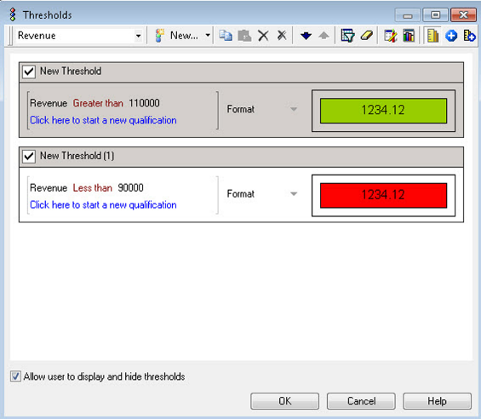

Creating and applying conditional formatting a specific criteria

*To format the cells, click on the box with the 1234.12 number. This will open a format editor similar to Excel with the familiar number, alignment, font, border, and background tabs.*

**Summary**

This finalizes the chapter. At this point, you should be able to point the differences between the Schema and the Public/Application Objects in MicroStrategy. You should also be able to create and understand the following Application Objects:

* Report
* Template
* Filter
* Metric

Additionally, you should now understand how to perform some basic Report manipulations such as Page-by, pivoting, sorting, drilling, exporting, and switching to graph mode, among others.

The next chapter will cover some important concepts and objects that will help the developer to enhance the reporting Application, such as custom Groups, Prompts, Drill Maps, and Intelligent Cubes.

**Advanced Reporting - Interacting with and Improving Your Reports**

At this point, you should be familiar with MicroStrategy and its objects, both Schema and Public. In the last chapter, we built some basic reports and manipulations, now it is time to learn about some more advanced objects that will enhance analytics and reporting, adding flexibility and improving performance and scalability.

The following topics will be covered in this chapter:

* What a MicroStrategy Custom Group is and how to create it
* What a MicroStrategy Consolidation is and how to create it
* Understanding the different types of prompts and how to create them
* What a MicroStrategy Drill Map is and how to create it
* What a MicroStrategy Intelligent Cube is, and how to create it

# Grouping data together – Custom Groups and Consolidations

When new data is needed on the reporting layer, for example a new Region or a new Product Category, it would need to be fed from the source systems to the database. Then, MicroStrategy can execute a query to report it. However, in some scenarios, due to time constraints or because of a very specific and customized requirement, you might want to group the data in a report to create sets, bands, quartiles, or simply to combine Attribute elements without having to modify the database. We will explore two objects that serve this purpose: Custom Groups and Consolidations.

The following is a quick reference table for a MicroStrategy Custom Group:

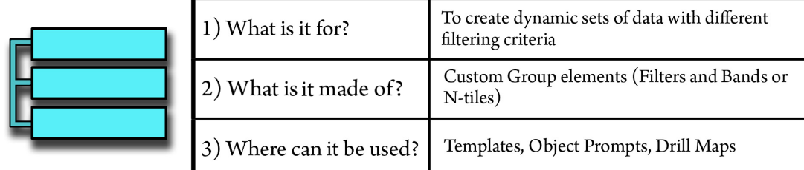

A Custom Group is an Application Object that creates dynamic sets of data in such a way that it gives the ability to create several mini-reports inside a Report. This object is based on another familiar one: the Filter. The developer would create one or more Filter qualifications in order to define what is called a Custom Group element. Then it would be possible to show Metrics calculated for that Custom Group element or by individuals that make up the group. Let's see an example. Suppose that you want to show the Top 5 products in your company and the Bottom 5 by Revenue. You would have two groups:

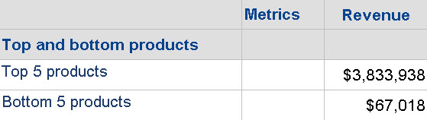

Displaying Top 5 products and Bottom 5 products by Revenue

Alternatively, you could also show the items within each group:

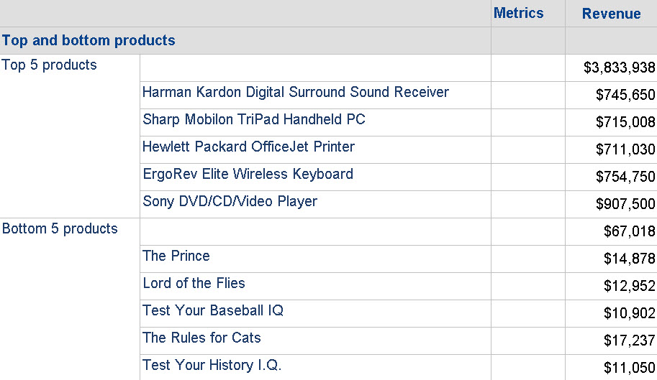

Displaying Top 5 products and Bottom 5 products with item names

*Custom Groups are SQL-intensive objects that create several SQL passes. Developers should try to use alternative options, such as two reports in a Dashboard, for the previous example.*

**Exercise – create a Custom Group**

In this exercise, you will learn to create a Custom Group.

1. In MicroStrategy Developer, log in to the MicroStrategy Analytics Modules Project Source.
2. Open the MicroStrategy Tutorial project.
3. Browse to the MicroStrategy Tutorial\Public Objects\Reports\My Exercises folder.
4. Right-click | New | Custom Group.
5. Using the Object Brower, locate the Revenue Metric (Public Objects\Metrics\Sales Metrics) |, and drag and drop it to the right to create a Custom Group Element. You will now see a Filter editor-like interface. You create the filter qualification just as you would do on a regular Filter. The only difference is that you need to establish the Output Level of the Filter. In previous exercises, when a Filter was created by default, the output level was the Report level, which implied that the Filter was applied to the lowest grain present in the Template. However, in a Custom Group, this level needs to be specified.
6. Create a qualification like this one (set the Output level to Item Attribute, from the Product folder) | OK:

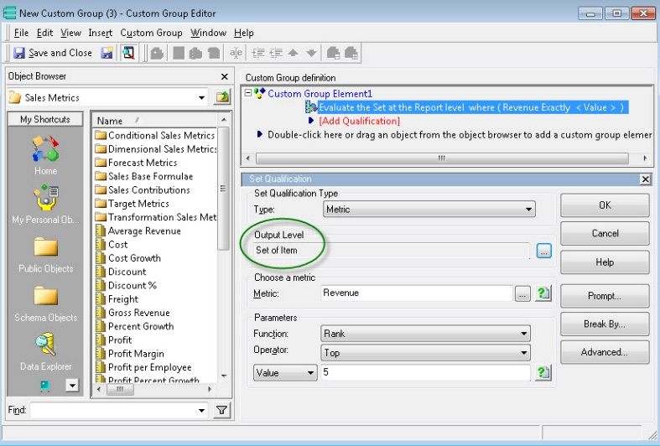

Setting the Output level

1. Right-click on Custom Group Element1 | Rename | Top 5 products.
2. Repeat this with a Bottom 5 qualification and name the Custom Group Element2 as Bottom 5 products.
3. Save and Close | name it Top and bottom products.
4. Create a new Report | Add the Top and bottom products Custom Group to the Template | add Revenue Metric| Execute the Report. You will see two rows, one for each set, corresponding to the qualifications you created | Save and close the Report | name it Top and bottom products Report.
5. Now, we will change the display options to show individual items in the group. Edit the Top and bottom products Custom Group | Right-click each of the two elements | Show display options and select the following:

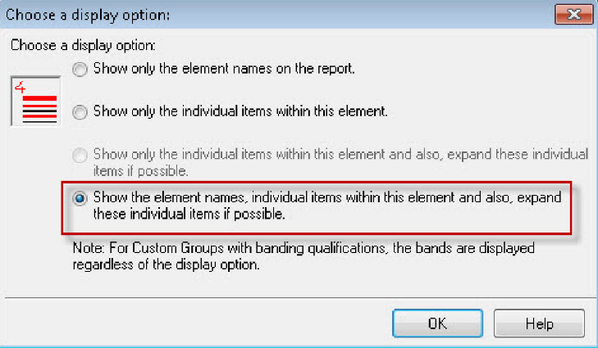

Changing the display options

1. Select Save and close | Re-execute the Top and bottom products Report. You will now see five individual products on each set.

The previous exercise demonstrates Custom Group elements created from Metrics. This is also called Set Qualification. However, the Filter can also be created using Attributes or other Reports. Additionally, there is an option to create a Group of Bands or N-Tiles (such as Quartiles). To access these options, instead of dragging and dropping the object from the Object Browser into the Custom Group Element, double-click on Add Qualification. You will see the following options:

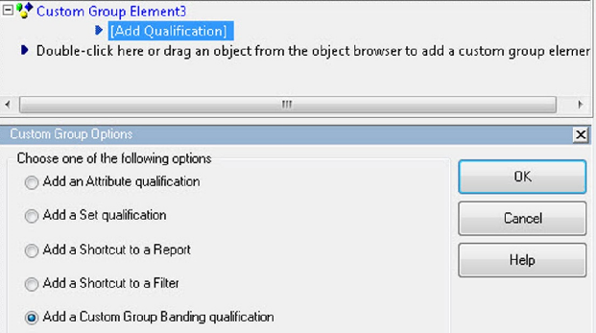

Selecting the option to create a group of bands

A Consolidation is an Application Object that creates static sets of data in such a way that a virtual Attribute can be built.

The following is a quick reference table for a MicroStrategy Consolidation:

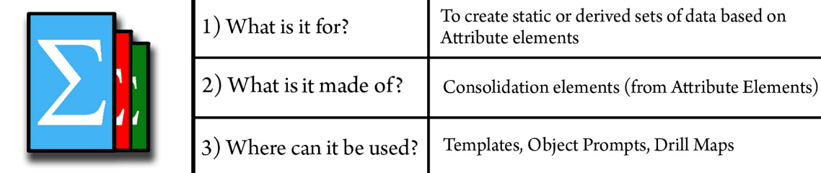

As opposed to Custom Groups, which are based on qualifications or Filters, Consolidations are built upon Attribute Elements. You will notice that when building a Consolidation Element, the Object Browser shows only the Hierarchies in the Data Explorer and therefore only Attribute Elements can be selected.

**Exercise – creating a Consolidation**

In this exercise, you will learn to create a Consolidation:

1. Browse to the MicroStrategy Tutorial\Public Objects\Reports\My Exercises folder.
2. Right-click | New | Consolidation.
3. Once the editor is open, click on the area labeled Click here to add new consolidation element.
4. Name the First Element South Region.
5. In the Object Browser, locate the and double-click Geography Hierarchy. Double-click on Region Attribute. You will see the Region's elements.
6. Holding the Control key, select South, Southeast, and Southwest | Drag and drop them into the expression window. You will see a new expression created: ({Region=South}  +  {Region=Southeast}  +  {Region=Southwest}).

*You can also use a different arithmetic operator. The expression indicates how all Metrics will behave when aggregated to that new Consolidation element. In the previous scenario, it will add or***consolidate***whichever Metric is on the Template for those Regions.*

1. Create another Consolidation Element | Name it North Central Region| create the following expression: ({Region=Central}  +  {Region=Northeast}  +  {Region=Northwest}).
2. Create another Consolidation Element | Name it Internet Channel | create the following expression: {Region=Web}.
3. Create one last Consolidation Element | Name it Foreign Region | create the following expression: ({Region=Canada}  +  {Region=England}  +  {Region=France}  +  {Region=Germany}).

Your final Consolidation should look like this:

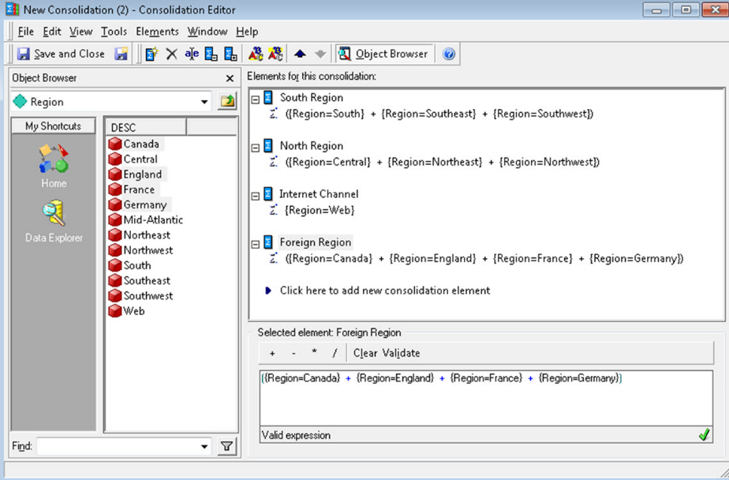

How the final consolidation should look

1. Save and Close | Name it Custom Regions.
2. Create a new Report | Add a Custom Regions and Revenue Metric | Execute the Report; it should look like this (note that there is no Revenue for Foreign Regions):

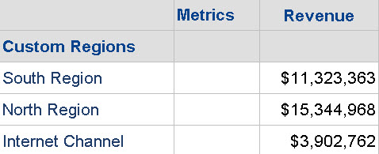

Custom Regions and Revenue

1. While in the executed Report, browse to Schema Objects\Attributes\Geography | Add the Region Attribute to the right of the Custom Regions Consolidation. You should now see how each Custom Region brakes into the corresponding Region.

*MicroStrategy does not validate whether the Consolidation created uses the same Attribute elements on all the Consolidation elements (for example, mixing Regions and Products will make no sense), or if one is missing or repeated (for example, adding Southeast to both the North and South Regions). It is the responsibility of the developer to make sure the Consolidation is created by conforming to the business logic.*

# Dynamic filtering and report creation – Prompts

Prompts are the most versatile Application objects in MicroStrategy since they provide flexibility to customize the SQL sent to the database, based on a user response to a question that is presented before Report execution.

The following is a quick reference table for this MicroStrategy Object:

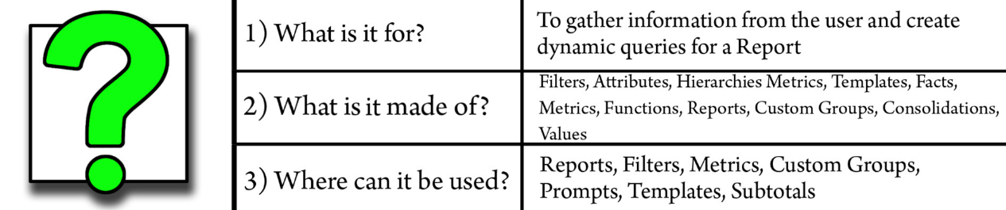

Basically, when a Prompt is inserted in an object, MicroStrategy places a wildcard on the corresponding portion of the SQL. After this when the user responds to the Prompt, that unknown SQL gets replaced accordingly.

**Understanding types of Prompts**

To better understand Prompts, it is necessary to explain the different types. Their type will determine what objects can be used to build them and how and where to use them.

1. Filter definition prompt:

* **What is it for?** To dynamically create a Filter based on the user response
* **What is made of?** A Filter definition on a Hierarchy, Attribute, Metric, or by directly picking Attribute elements
* **Where can it be used?** Since it is a dynamic Filter, it is possible to use it wherever a regular Filter can be used, such as Reports, other Filters, Custom Groups, and even within another Prompt (Object prompt, see later)

1. Value prompt:

* **What is it for?** To input a value using a text box (or a date box or number box); then, this value can be used to complete another object's definition, such a Filter or a Metric
* **What is made of?** A text box, a number box, or a date box (free form input)
* **Where can it be used?** While creating a Filter or a Metric

1. Level prompt:

* **What is it for?** To define the aggregation level (dimensionality) of a Metric
* **What is made of?** Attributes and Hierarchies
* **Where can it be used?** Within the Metric's dimensionality

1. Object prompt:

* **What is it for?** To replace virtually any object in MicroStrategy
* **What is made of?** Attributes, Metrics, Templates, Facts, Filters, Reports, Functions and Operators, Custom Groups, and Consolidations
* **Where can it be used?** Mostly in Templates, but it can also be used on Filters, Metrics, Custom Groups, Subtotals, and even inside another Object Prompt (nested Prompts)

*It is recommended to use the same type of object when creating an Object Prompt. Its usage will depend on what is inside it. For example, it won't be possible to place an Object Prompt inside a Template if it has Filters inside, because Filters can't be placed on Templates.*

**Exercise – create some prompted Reports**

In this exercise, you will learn to create several types of Prompts:

1. Browse to the MicroStrategy Tutorial\Public Objects\Reports\My Exercises folder.
2. Right-click | New | Prompt. You will see four radio buttons corresponding to each of the four types of Prompts described before.
3. Select Filter definition prompt | Choose from an Attribute element list | Next.

*The Filter definition prompt is commonly used in a pair with the Attribute element list option. Try the other three options to see the difference. Basically, these options will let the user build a Filter on the fly, or dynamically create a Filter qualification.*

1. Select the Call Center Attribute (Under Geography) | Next.
2. Leave the default option (List all elements) | Next | Change Display properties Title and Instructions to anything you want | Set Minimum number of answers to 1 | Maximum number of answers to 3 | Set Prompt answer is required.

*If you want to make a prompt optional, leave this last option unchecked.*

1. Click Next | Finish | Save the object as Choose your Call Center.
2. Create a new Report with Call Center and Month Attributes, and the Revenue Metric | Add no Filter.
3. In the Report editor, browse to the My Exercises folder | Drag and drop the Choose your Call Center Prompt into the Report Filter | Execute the Report. You should see a list of Attribute elements (red cubes) listing all Call Centers in the database. Select one, two, or three Call Centers from the US | Click Finish.

*You can test the Prompt limits you established: the Prompt is required (click Finish without answering it) and you need a minimum of one and a maximum of three selections.*

1. When you execute the Report, you have the option to re-Prompt using the following button:

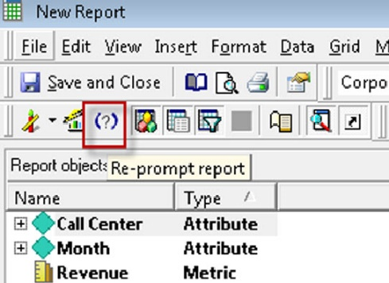

Re-Prompt button

1. Try a few other selections to see how the result varies; also, check the SQL view and verify that the Call Centers selected appear in the WHERE clause | Save and Close | Name it Prompted Report. You will see the following options:

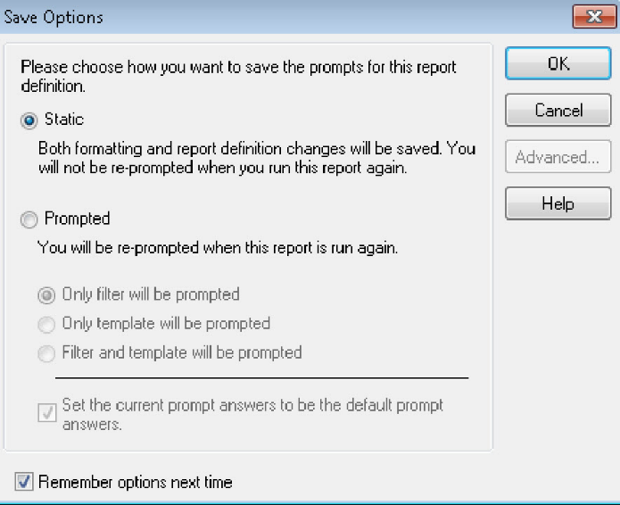

Different selections to see how the result varies

*The first option, Static , will eliminate any Prompt within the Report definition, whereas the second option, Prompted, will keep them in the Filter, Template, or both.*

1. Select Prompted | Filter and template will be prompted | OK.

*The first option, Only filter will be prompted, makes the template static if there are prompts inside it. The second option, Only template will be prompted, makes the filter static if there are prompts inside it. The third option, Filter and template will be prompted, will always prompt the user regardless of where the prompts are.*

1. Create another Prompt, right-click | New | Prompt.
2. Select Object prompt | Next | Add | Browse and select Cost and Profit Metrics (inside the Sales Metrics folder) | OK.
3. Select Next | Change Display properties Title and Instructions to anything you want | Finish | Name it Choose your Metric.
4. Edit your Prompted Report (right-click | Edit) | Drag and drop the Choose your Metric Prompt into the Report's Template.

*If the Object Prompt contains an object that usually can't go inside a Template, such as a Filter, this action would not be valid and thus MicroStrategy would not allow dropping it in the Report's Template.*

1. Execute the Report | You should see now two Prompts, one for the Filter (Choose your Call Center) and one for the Template (Choose your Metric).
2. Select Cost and/or Profit Metrics | Select your Call Centers. Notice how your previous selection is active, since you left the corresponding checkbox marked |Select Finish (don't close the Report).
3. We will now create a local Filter with a Value prompt. Go to the Design view | Drag and drop the Year Attribute into the Filter section | For Qualify On, choose from the ID drop-down.
4. Leave the operator Exactly | In the dropdown below it, select Simple Prompt (which is the same as a Value Prompt).
5. Leave Display properties as the default | Set Minimum value to 2014 and Maximum value to 2017 | Next | set the Default value to 2015 | Finish | OK | Save and Close | Use the same Prompt options as before (Filter and Template).
6. Execute the Prompted Report. There are now three prompts. Answer them, and when you get to the Value Prompt, it should ask for the year | Type 2016 (Notice the default is set to 2015) | Finish | Save and Close | OK (in the Prompt options).

*MicroStrategy won't validate that the input to a Value Prompt corresponds to the Attribute (in this exercise, Year). It only adds the user response to the WHERE condition. If the user responds with a value that is not valid, the Report will not return any results.*

**Drilling paths – Drill maps**

Drill Maps are Application Objects that provide navigation paths from a Report to levels of aggregation different from what is shown in the Report view or Template.

The following is a quick reference table for this MicroStrategy Object:

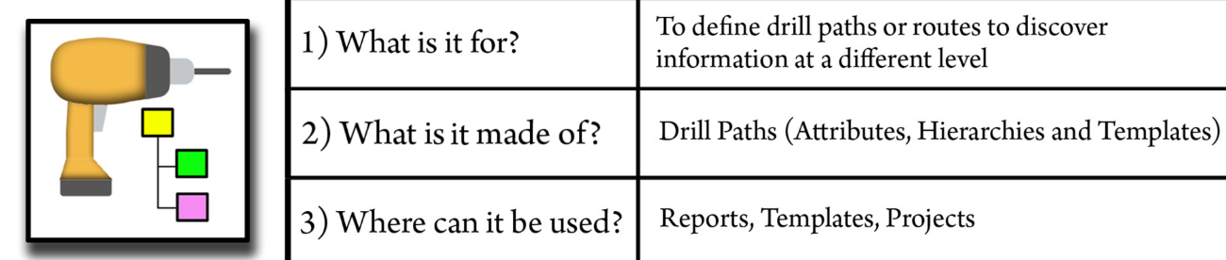

When a user executes a Report and right-clicks on any part of the view (a Template with data), three paths are shown by default:

* **Up**: Shows any parent (or grandparent) Attribute from the one where the drill was initiated.
* **Down**: Shows any child (or grandchild) Attribute from the one where the drill was initiated.
* **Other directions**: Also known as **Across**. It will show all user-defined Hierarchies in the Project.

This behavior can be overwritten if a Custom Drill Map is associated with the Report. When a Drill Map is created, the developer decides what Attributes or Hierarchies are shown in each of the three mentioned paths (Up, Down, and Across). In addition, it is also possible to drill to an entirely different Template with diverse Attributes and Metrics.

**Exercise – create a Custom Drill Map**

In this exercise, you will learn to create a Drill Map and associate it to a Report:

1. Browse to the MicroStrategy Tutorial\Public Objects\Reports\My Exercises folder.
2. Create a new Report with the Call Center Attribute and Revenue Metric | Execute the Report | Right-click on any Call Center | Drill. Check what the default Drill Map looks like. It should show three paths. Notice how the Up path shows Attributes such as Country, Manager, Region, and Distribution Center.
3. Save and Close | Name it Call Center Revenue.
4. Let's think of a scenario where the options available to the users are restricted to some Attributes; perhaps the Metrics in the Report are not available at those levels, or simply to avoid a query that will return a large amount of data. To achieve this, you will need to create a Drill Map. Right-click | New | Drill Map. The Drill Map editor shows the four Drill Paths: Up, Down, Across, and Template.

*You can define in the Drill Map editor which Attributes and/or Hierarchies will become available to each Drill Path.*

1. Drag and drop the Region Attribute onto the Up path | Leave the Down path empty | Drag and drop the Category Attribute and Time Hierarchy onto the Across path | Leave the Template path empty.
2. Click on the Up | Region Attribute. Notice that there is a group of Properties available at the right side of the Drill Map editor:

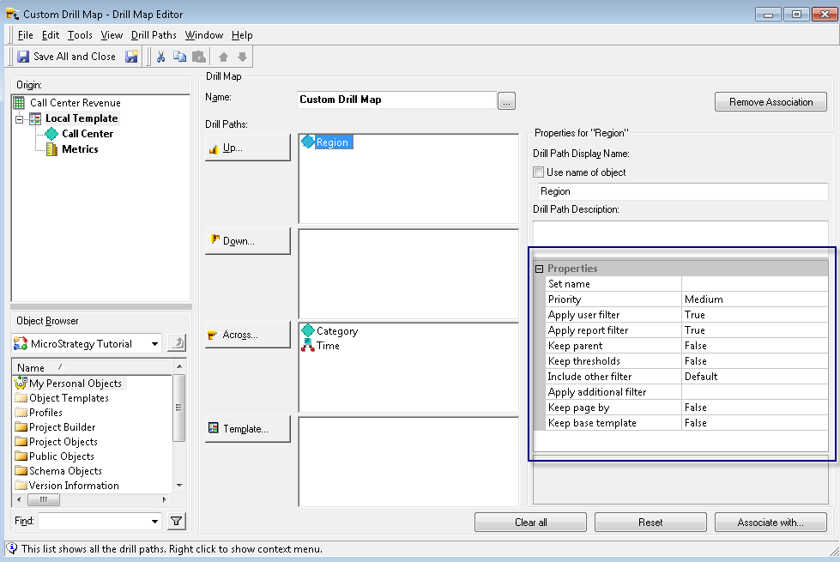

Region Attribute

*These properties will control the behavior of the Drilled Report (often referred as a child Report). You can bring over the Attribute from which you initiated the drill (referred to as the parent Attribute) to the child Report, and bring over the Report Filter, the user selection (user Filter), and so on.*

1. Click on the lower-right button, Associate with… | Locate the Call Center Revenue Report created at the beginning of this exercise | Select it and move it to the right | Make sure Local Template, Call Center, and Metrics are checked | OK.

*You can specify which objects within the Report's template can initiate a drill action.*

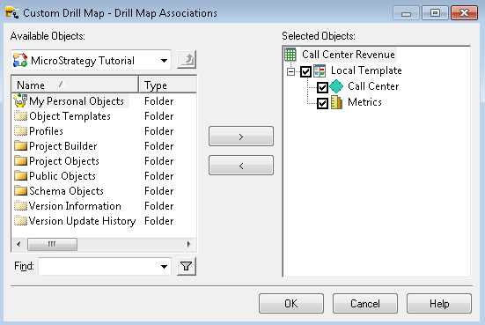

Specifying which options are displayed in the report

1. Save and Close | Name it Custom Drill Map.
2. Execute your Call Center Revenue Report | Right-click on any Call Center | Drill. Notice that there are only two drill paths (the Down path has been removed) | Test that the Up and Other directions paths contain the objects you specified.
3. Drill Up to Region | Close the child Report | Drill Other directions to Category | Close the child and parent Reports.
4. We will now create a new Template to create a Drill on the Template path. Create a Template with Customer and Payment Method Attributes, and Revenue and Unit sold Metrics | Save and Close | Name it Customer detail.
5. Edit Custom Drill Map | Drag and drop the Customer detail Template onto the Template path | Save and Close.
6. Execute your Call Center Revenue Report | Right-click on any Call Center | Drill To template | Customer detail. Verify that the child report shows Customers in the source Call Center with their Revenue and Units Sold.

# Publishing data sources – iCubes

Intelligent Cubes, also known as iCubes, are Application objects that allow developers to pre-calculate and publish data sources. These data sources are stored in memory in the Intelligence Server so that result sets for Reports and Documents (Dashboards) can be retrieved immediately, without having to wait for the SQL to be executed against the database.

The following is a quick reference table for this MicroStrategy Object:

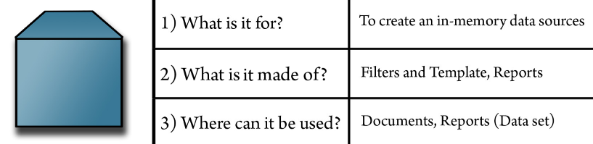

When a Report uses an iCube as a source of data, as opposed to a relational database, it is referred to as a Data set. A single iCube can source many Data sets. Intelligent Cubes improve performance and user experience by pre-aggregating and pre-calculating the data. In order to be able to create, use, and manage iCubes, it is necessary to license and install MicroStrategy OLAP Services.

The iCube creation process is very similar to Reports: Right-click | New Intelligent Cube | Then, add a Template and Filter. There are a few exceptions/differences when compared to Reports:

* It is not possible to add Prompts to an iCube, since the Prompts require on-the-fly changes to the SQL that are sent to the database. Nevertheless, it is possible to add a Prompt to a Data set that points to an iCube. The Prompt will be calculated and resolved by the Analytical Engine with the data available in the iCube, and will produce no SQL changes.
* It is not possible to add Consolidations or Custom Groups to an iCube.
* When an iCube is executed, no data is shown. An iCube that is executing is said to be publishing. This process is what refreshes the data within the iCube. Once the iCube is published, data can be visualized through Data sets using either the iCube or Documents (Dashboards).

To create a Data set from an iCube, simply right-click the iCube | Create Report. To use the Data set, you'll first need to publish the iCube. Then, any changes to the data or structure of the iCube will impact the associated Data set(s) accordingly.

The iCube gets published when it is executed in Developer. However, it should be scheduled to automate the process. To subscribe an iCube to a certain Schedule for automatic refreshing, right-click the iCube | Schedule Delivery to | Refresh Cube | Pick up a Schedule | OK.

*You can only create iCube subscriptions on a 3-Tier Project source. Therefore, if you try this in our 2-Tier environment, this option won't be available.*

Refer to [Chapter 7](https://learning.oreilly.com/library/view/microstrategy-quick-start/9781789136241/aac45770-f3d9-4af3-913d-55f7105d3290.xhtml), *Administration – Maintaining and Monitoring your Project* for details on creating and managing Schedules.

Once an iCube is published/refreshed, it can be managed (deleted, loaded into memory, unloaded, and so on) in Developer.

Refer to [Chapter 7](https://cdp.packtpub.com/microstrategy_essentials/wp-admin/post.php?post=27&action=edit#post_30), *Administration – Maintaining and Monitoring your Project* for details on monitoring and managing iCubes.

**Summary**

This chapter went beyond the basics of MicroStrategy with some less common Application Objects that allow developers to create more flexible, scalable, and dynamic solutions. You should be able to create and understand the following objects:

**Application Objects**

* Custom Group
* Consolidation
* Prompt
* Drill Map
* Intelligent Cube (iCube)

We will learn in the next chapter how to import data from the MicroStrategy Web interface, and how to create and visualize both Enterprise Certified Dashboards and self-service Dashboards.

**Dashboarding - Creating Visual Reporting**

It is time to use all of the skills acquired so far to create visual reporting through Dashboards and Documents. In this chapter, we will be using MicroStrategy Developer in conjunction with its web-based client counterpart, MicroStrategy Web.

The following topics will be covered:

* Understanding how to import data using MicroStrategy Web
* Explaining what a MicroStrategy Document is and how to create one
* Explaining what a MicroStrategy Dashboard is and how to create one

**Importing Data**

There are times when developers and analysts need a fast and reliable way to leverage a data source to satisfy an immediate reporting need. However, they don't always have access to the enterprise database or data warehouse. It is possible, then, to use MicroStrategy Web to import data into an Intelligent Cube and then use it to build a dashboard or document.

*It is necessary to have a 4-Tier environment configured to import data from MicroStrategy Web.*

To import data on MicroStrategy Web 10, follow these steps:

1. Click on the Add External Data icon that appears once the user logs in to the project:

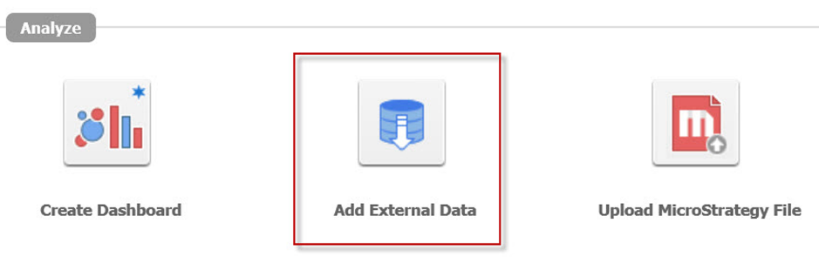

1. Select the source:

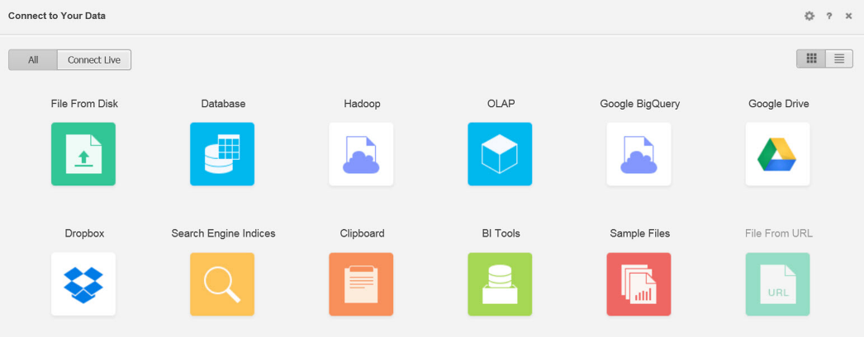

Selecting the source

MicroStrategy connects to a variety of data sources, from files, such as Excel or CSV, to relational databases and nonrelational sources, such as data from a web page. Once the data is imported, MicroStrategy saves it as an Intelligent Cube. The cube can be refreshed and scheduled as a normal cube and used to build documents and dashboards.

1. Prepare the data: The developer decides what to bring and basically converts the data into either Attributes or Metrics.

# Exercise – import data

In this exercise, you will import an Excel file that contains data from the MicroStrategy Tutorial database into an Intelligent Cube. Then, this Cube will be used to create a Report:

1. In MicroStrategy Web, log in to the MicroStrategy Analytics Modules Project Source.
2. Open the MicroStrategy Tutorial Project.
3. On the Home screen, select Add External Data | File From Disk | Choose Files (you can also drag and drop the TutorialData.xlsx Excel file).  You can find the Excel file in the GitHub Repository (<https://github.com/PacktPublishing/MicroStrategy-Quick-Start-Guide>).
4. Click on Prepare Data | Wait until the file gets uploaded.

*By default, MicroStrategy uses the first row in the Excel file as headers for each Attribute and Metric. However, you can add, update, or remove headers and columns during the data preparation phase.*

1. Notice that MicroStrategy Web automatically recognizes the columns as either Attributes or Metrics. Nonetheless, you can individually set each to Attribute or Metric by choosing Convert to.
2. There is an extra column labeled Metrics. Let's get rid of it. Right-click | Select Do Not Import.
3. Click on Finish | Save in | Browse to the My Exercises folder | Name it Imported Cube, then click on Save.
4. Now we are going to test the imported data. After clicking Save, there is a window with options for creating either a Dashboard, Document, or Report. Choose Report.
5. The Web Report Editor will open. This is similar to Developer. Drag and drop the Category and Call Center Attributes to the rows. Drag the Profit and Cost Metrics to the section labeled Drop Metrics here to add data | Drag and drop the Year Attribute to PAGE-BY:

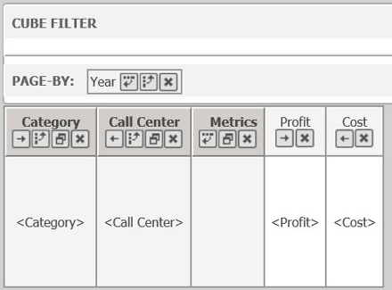

1. Execute the Report by clicking on the top-right icon (a Report with a Thunder), then click on Report Home | Save As.. | Category Dataset.

*You can open Developer and locate, in the My Exercises folder, your newly created objects. Try to run the Category Dataset from Developer.*

1. This finalizes the exercise.

# Creating enterprise-certified dashboards – Documents

Documents are the ultimate analytics and business intelligence tool. They are Application Objects, which provide final users with the combination of visual representation of key business indicators and interactivity, delivered in a variety of formats (Dynamic HTML, PDF, Excel, and Prints) and media (MicroStrategy Web, MicroStrategy Mobile, and email).

The following is a quick reference table for a MicroStrategy Document:

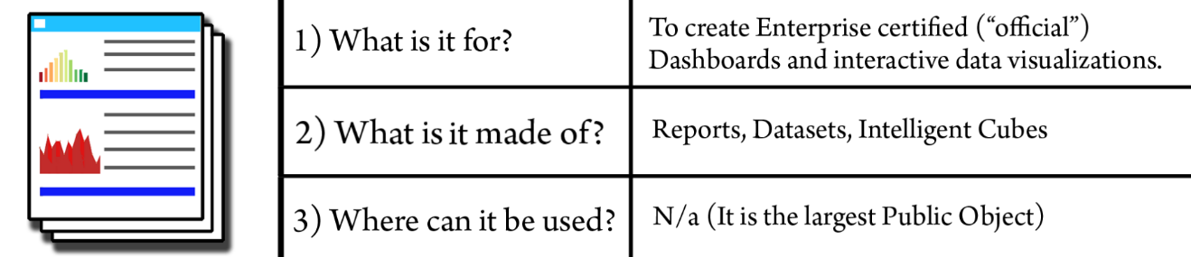

Documents can be developed using either MicroStrategy Web or MicroStrategy Developer. A Document can be created from one or more Intelligent Cubes or Datasets. Intelligent Cubes provide better performance and deliver a much better user experience since the data is already stored in-memory and retrieved by the Document when it is executed. Conversely, if the Document is based off a Report, when the Document gets executed, the Report (or Reports) needs to be executed against the database.

*A Dataset is a Report used in a Document. It can be created from an Intelligent Cube or result from SQL executed against the Data Warehouse.*

The following diagram depicts which objects could be used to create a document:

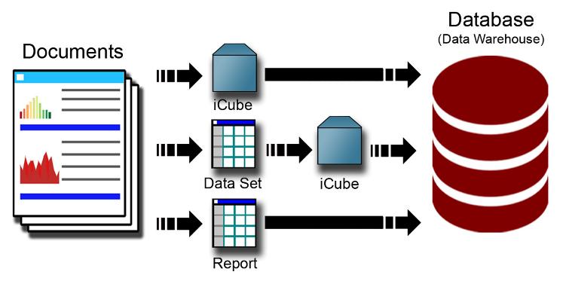

**Document structure**

The first step towards creating a MicroStrategy Document is to select the Sources (Datasets, iCubes, or Reports). You can always add or remove Data Sources at a later point in time. When a Blank Document is created, the editor shows by default the following sections:

* Page Header
* Document Header
* Detail Header
* Detail
* Detail Footer
* Document Footer
* Page Footer

These sections are usually only utilized when the document created is printed or delivered in PDF. For dashboard creation, the only section needed is the Detail Header, which becomes the Body of the document.

In the lower left section of the Document Editor, the developer can toggle between Datasets and Property List, as you can see in the following screenshot:

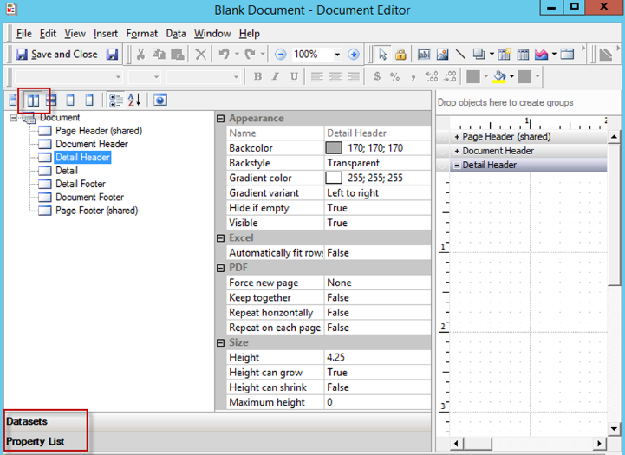

* The Datasets view allows the developer to see the Attributes and Metrics available from each source to build visualizations.
* The Property List view can be further divided into Document Structure and Control/Objects Properties (click on the icon with the two vertical rectangles).

To remove the unused document sections, go to Format | Document Properties | Sections and uncheck any unwanted sections.

*If the Detail Header is kept, this section is automatically converted into the Body.*

**Document controls**

Once the data sources have been added to the document (Datasets, iCubes, or Reports), it is time to start designing how the data should be presented and how the user will interact with it. Any item that can be added to the document is called a **control**. These are the most basic types of controls that can be used in a document:

* Text
* Image
* Line
* Shape

There are three other control types that each serve a specialized purpose:

* **Data** **Controls**: Data can be added to the document as a **Grid**, **Graph**, or **Widget** (Visualization)
* **Filtering Controls**: **Selectors** are used to limit the information of the data controls in an interactive way
* **Organizing Controls**: **Panels** and **Panel Stacks** are used to group controls together and help organize the document layout

In the following exercise, we will learn how to create and use some of these controls.

**Exercise – creating a basic document**

In this exercise, you will create a document using the imported data from the (TutorialData.xlsx Excel file). The document will feature a grid, a graph, and some selectors to provide the user  with interactivity and filtering options:

1. In MicroStrategy Developer, log in to the MicroStrategy Analytics Modules Project Source.
2. Open the MicroStrategy Tutorial Project and create a new document in the My Exercises folder | Select Blank Document and click OK.

*You can also create documents from MicroStrategy Web in a similar way as you do in Developer. To visualize and interact with the document, it is necessary to open it in MicroStrategy Web as Developer doesn't provide the interface to interact with the document's controls.*

1. Browse and locate the Category Dataset created in the previous exercise. Once you double click on it, the Document Editor will open up. Verify that the dataset is shown on the left pane.
2. Remove all document sections with the exception of Detail Header.

*Open the Format menu | Document Properties | sections.*

1. Switch the Datasets left panel to Property List. Make sure both the Document structure and the Control Property window are shown by selecting the second icon on the left pane (two vertical rectangles). Verify that the Body is the only section shown in the Document. Click on Document in the Document structure tree and change the Width to 11, as shown in the following screenshot:

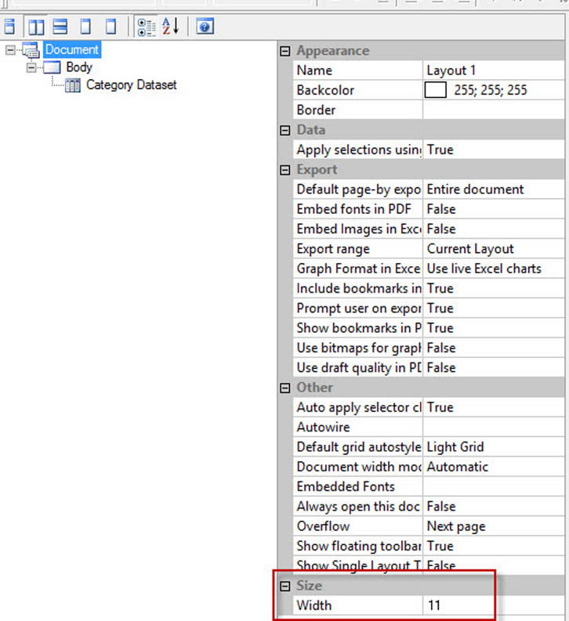

1. Click on the Body in the Document structure tree and change the Height to 6.5.
2. Switch back to the Dataset pane and drag and drop the Category Dataset to the Body. Switch to the Property List pane, **making sure the newly inserted Grid is selected** | Change the following properties:
   * Backcolor: White (255; 255; 255)
   * Border (click on … to open the window): Remove any border then click OK
   * Left: 1.9
   * Top: 1.125
   * Height: 5
   * Width: 3.625

*The Property window is a contextual pane. It will change depending on which control is selected in the document.*

1. Now we will insert some controls. Go to Insert | Text and with the cursor create a rectangle anywhere in the Body. Type Bookstore Dashboard. With the text control selected, change the following properties:
   * Backcolor: White (255; 255; 255)
   * Font: Arial Black, Size 14
   * Left: 3.875
   * Top: 0.5
   * Height: 0.4
   * Width: 3

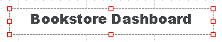

1. Choose Save and Close and name it My first Document.
2. Now we will test our document. Open MicroStrategy Web and log in to your Project. Browse to the My Exercises folder and click on My first Document.
3. Let's add another source. Return to Developer and right-click on Imported Cube | Create Report. Add a Subcategory Attribute and Revenue Metric to the Template | Save and Close | Name it Subcategory Dataset.
4. Edit My first Document | Go to the Data | Add Dataset | Locate Subcategory Dataset. You should now see the two Datasets on the left pane.

*If the object doesn't show up when you click Add Dataset, change the Object type dropdown to the corresponding object.*

1. Drag and Drop the Subcategory Dataset to the right side of the existing Grid | right-click on Graph | View Mode | Graph View.
2. With the Graph control selected, change the following properties:
   * Backcolor: White (255; 255; 255)
   * Border (click on … to open the window): Remove any border and click OK
   * Left: 5.875
   * Top: 1.125
   * Height: 4.625
   * Width: 4.625

*If you double a data control such as a grid or a graph, the upper menu bar changes to provide a different set of commands and formatting options.*

1. Now we will do some formatting on the graph:
   * Double click on Subcategory Graph and go to Gallery | Horizontal Bar | Absolute.
   * Go to Graph | Graph Options | Go to the Horizontal Bar Options section on the left. Click on All Text Format | Change Size to 10 and Color to Black. Then, go to Display section | Uncheck Show Legend | Go to Titles section |Value Title (Y) and type Revenue. Go to Series section and check Show Data Labels, then click OK:

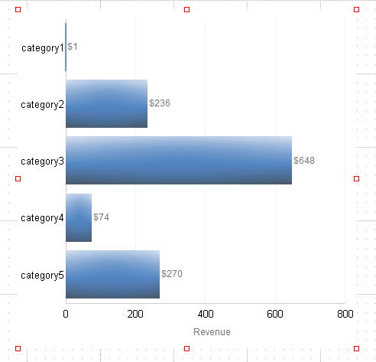

1. Now we will do some formatting on the grid. Double click on the Category Grid control and go to the Grid menu on the top. Choose AutoStyle Selected | Corporate | Save the Document. Open MicroStrategy Web and run the document again:

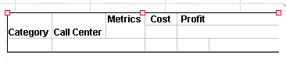

1. You might have noticed that the document is very simple, lacks interactivity, and is far from good-looking. This is because it is necessary to format every control, position and distribute them, and, most importantly, provide the user with a way to interact with the data. Let's make a few more changes.
2. Return to Developer | Edit the Document | Minimize the Document Editor in such a way that both the My Exercises folder and its contents and the Document Editor, are visible at the same time. Drag and drop the Imported Cube into the left Datasets pane of the document.

*If the Document Editor window disappears when you click on the Imported Cube, click on the object without releasing the left mouse button and, while holding it (don't drop it yet), press Alt + Tab to switch to the Editor again and drop the Imported Cube within.*

1. In the Document editor, go to Insert | Selector | Drop-down and draw a rectangle to the left of the grid.
2. Right-click on the selector | Properties | General tab | Name: Month Selector | Selector tab | Source dropdown | Month | Click on Manual Targets on the lower-right corner. Disregard the warning message and click OK.
3. With the selector control selected, change the following properties:
   * Left: 0.1
   * Top: 2
   * Height: 0.3
   * Width: 1.7
   * Show title bar: True
   * Title: MONTH
4. Repeat the process to add a selector but now with the Year attribute. Make sure that on the Selector tab, the Category Dataset, Subcategory Dataset, and Month Selector are selected **targets** | OK.

With the selector control selected, change the following properties:

* Left: 0.1
* Top: 1.46
* Height: 0.3
* Width: 1.7
* Show title bar: True
* Title: YEAR

1. Add a text control and write TIME SELECTIONS. With the text control selected, change the following properties:
   * Backcolor: 0; 109; 145
   * Left: 0.1
   * Top: 1.125
   * Height: 0.3
   * Width: 1.7

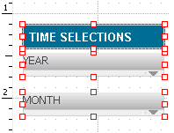

1. Save and Close the document.

*The time-based selectors that we have added***are not present in the Datasets***. If you execute the document and test the selectors, you will notice they won't affect the grid or the graph.*

1. Edit both Category Dataset and Subcategory Dataset and add Year and Month Attributes | Save and Close | Execute the Document | Verify that your selectors change the data on both the grid and graph and that the YEAR sector also changes the Months accordingly. If this is not happening, make sure the Targets on each selector are set correctly.

*As you can see, the grid and graph now show data from all categories. We want to restrict it to Books only.*

1. Edit  your Document in Developer | Right click on the Grid | Edit View Filter | New | Field | Category | In list | Select Elements | Books | OK. Then, Save and Close the document:

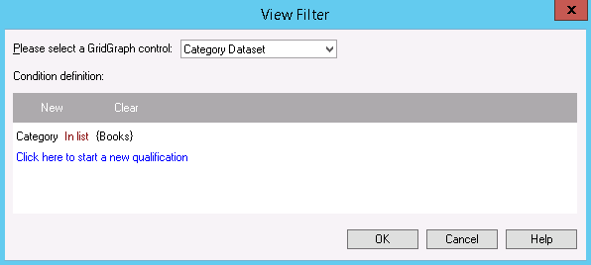

1. Edit your Subcategory Dataset | Add Category to the Template, then Save and Close the Report.

*This will allow you to create a View Filter on the graph too.*

1. Edit your Document | Add a View Filter on the Graph for Books Category too | Save and Close the Document | Execute the Document in Web.

Extra credit

1. Add Region and Call Center Attributes to the two datasets and insert two selectors to the document, one for Region (dropdown) and one for Call Center (check box). Your final dashboard should look like this one:

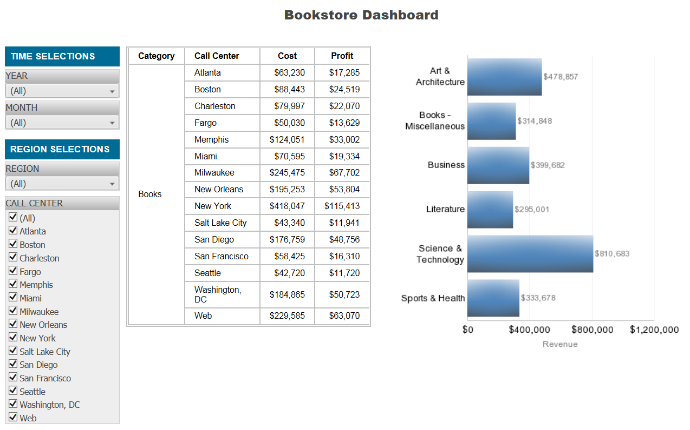

1. This finalizes the exercise.

*The documents and dashboards can also be visualized in MicroStrategy Mobile. The same objects might not be used. It is recommended to check whether the document dimensions are appropriate for the device (for examples iPad or iPhone).*

# For the self-serving enthusiasts – web Dashboards

An enterprise-certified dashboard is a set of reports and visualizations that have been put together typically by developers or IT specialists in conjunction with business partners. The developing cycle usually passes through different phases such as building, testing, user acceptance test (UAT), and production deployment. These types of dashboards and reports are built to be consumed by multiple users company-wide. However, in some scenarios, there might be a requirement to create reporting applications for a smaller set or even an individual in a more agile way. In this situation, a self-service approach might be appropriate to satisfy such a need.

The following is a quick reference table for a MicroStrategy Dashboard:

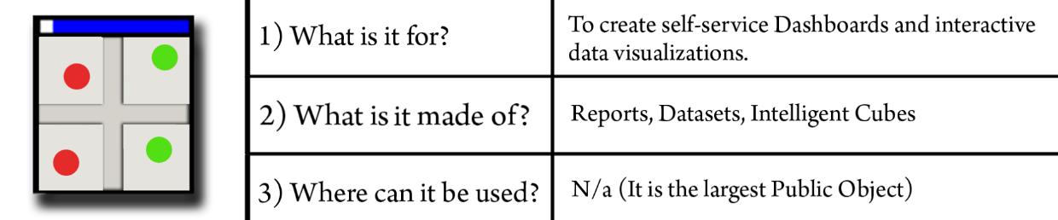

In conjunction with the data-importing capabilities we have covered at the beginning of this chapter, MicroStrategy offers the creation of self-servicing solutions through Application objects called Dashboards (formerly named Visual Insight). It is important to understand the difference between the object called Document, which can generate enterprise-certified dashboards, and the object called Dashboard that is tied with MicroStrategy self-servicing capabilities.

The Dashboard object can only be created and edited using MicroStrategy Web. In Developer, it is only possible to see the object, rename, move, or delete it; Developer doesn't offer editing or creation capabilities for Dashboards.

*If you try to edit a Dashboard object from Developer, it will be converted permanently into a Document so be careful. MicroStrategy alerts about this irreversible change though.*

**Exercise – creating a dashboard**

In this exercise, you will create a self-service dashboard using the imported data from the (TutorialData.xlsx Excel file ). Take the following steps:

1. In MicroStrategy Web, log in to the MicroStrategy Analytics Modules Project Source.
2. Open the MicroStrategy Tutorial Project.
3. Locate the Imported Cube and right-click on Create Dashboard.

*Note that the option to Create a Document in MicroStrategy Web from an iCube it is also available.*

1. The first time you create a dashboard, a tutorial splash screen will present the most important sections of the editor, as shown in the following screenshot:

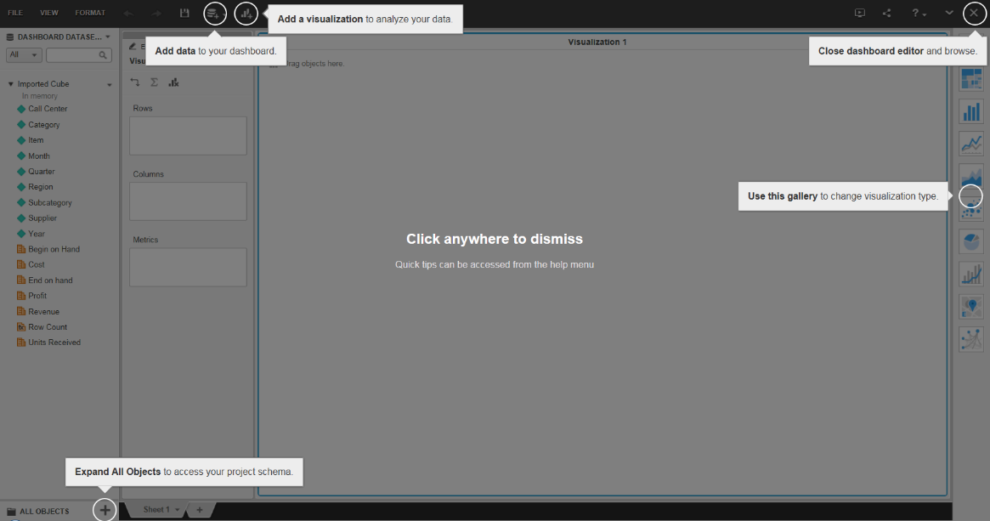

1. Drag a Region Attribute, and Revenue and Cost Metrics to the Visualization area. A Grid visualization will be created, similar to a Grid Report.
2. On the Visualizations bar (right side of the editor) select the sixth icon which corresponds to the Bubble chart.
3. Once the graph is generated, you can control which Metric is associated with *y* or *x* axes by dragging the corresponding object to either the Vertical or Horizontal box. Similarly, you can control Color and Size by adding or removing objects from or to those boxes. Drag the Profit Metric to the Size box | Remove Revenue from the Size box.
4. Add Revenue to the Color box. Right-click on Revenue in the Color box, choose Thresholds and then choose the color Red-Orange-Green. Click on OK.

*You can add as many sheets as you want within the same dashboard by clicking the + symbol (similar to Excel).*

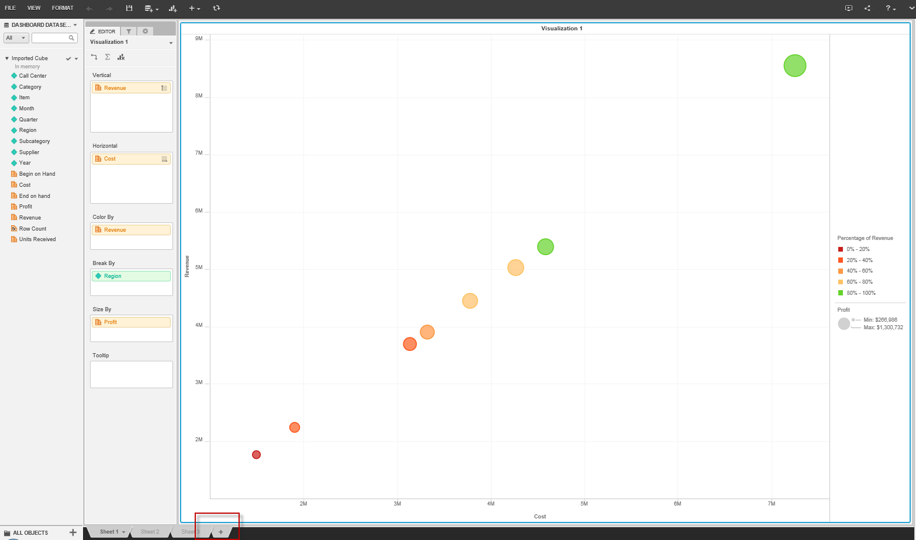

1. Use the disc icon in the top bar to save or choose File | Save and name it My first Dashboard and click OK.
2. This finalizes the exercise.

*Similar to documents, dashboards can also be visualized using both MicroStrategy Web and MicroStrategy Mobile.*

**Summary**

This chapter was all about using data to create visual reporting. We started with understanding MicroStrategy data-importing capabilities. Then we covered the following Application Objects:

* Document
* Dashboard

We will switch gears in the next chapter by introducing the main configuration objects that allow administrators to assign user and group access to projects, manage Project privileges, and access control to objects.